Internship Report
On
Technology-Enabled Supply Chain Management in the Commercial Vehicles Industry:
A study of Supply Chain Management at Tata Motors Commercial Vehicles, Lucknow Plant through PTL, HHT, Samprawah, Inventory Control and Lean Manufacturing Practices
Submitted in partial fulfillment of the requirements for the award of the degree of
Bachelor of Technology in Production & Industrial Engineering
Submitted by
Tanishq
College Registration no:2024UGPI041
Internship Organization

Tata Motors Limited
Commercial Vehicles Business Unit (CVBU)
Industry Guide
Mr. Piyush Mehrotra, Deputy General Manager, Tata Motors Commercial Vehicles Lucknow
Duration of Internship
June 5,2026 – July 6,2026
Department of Production and Industrial Engineering


National Institute Of Technology Jamshedpur-831014

CERTIFICATE
This is to certify that Ms. Tanishq ,a student of Bachelor of Technology in Production and Industrial Engineering, National Institute of Technology (NIT) Jamshedpur, has successfully completed the Summer Internship Project titled:Technology-Enabled Supply Chain Management in the Commercial Vehicles Industry:A study of Supply Chain Management at Tata Motors Commercial Vehicles, Lucknow Plant through PTL,HHT,Samprawah,Inventory Control and Lean Manufacturing Practices during the period of 5 June ,2026 to 6 July,2026 at Tata Motors Limited, Commercial Vehicles Business Unit, Lucknow Plant.
The project work carried out by the student under the guidance of the Supply Chain Management Department is original and has been successfully completed during the internship period.The student demonstrated sincerity, dedication, and a keen interest in understanding various aspects of supply chain management and automotive manufacturing operations.
We wish her every success in all her future endeavours.

Industry Guide
Mr. Piyush Mehrotra
Deputy General Manager
SCM & Warehousing Department
Tata Motors Limited
Commercial Vehicles Business Unit (CVBU)
Lucknow Plant

Faculty Guide
Department of Production and Industrial Engineering
National Institute of Technology Jamshedpur-831014

Duration of Internship: 5 June 2026 – 6 July 2026
Place: Lucknow, Uttar Pradesh

ACKNOWLEDGEMENT
I sincerely thank Tata Motors Limited, Commercial Vehicles Business Unit, for providing me with the opportunity to undertake my summer internship in the Supply Chain Management Department. This experience enhanced my understanding of modern supply chain operations and industrial practices.
I am especially grateful to Mr. Piyush Mehrotra, Deputy General Manager, Tata Motors, for his valuable guidance, support, and encouragement throughout the internship. His mentorship helped me gain practical insights into warehouse operations, inventory management, PTL, HHT,Samprawah, lean manufacturing, and digital supply chain systems.
I also extend my thanks to all the executives and team members of the Supply Chain Management Department for their cooperation and knowledge sharing. Their support greatly contributed to the successful completion of my internship and report.
I am thankful to the Department of Production and Industrial Engineering, National Institute of Technology Jamshedpur, for providing this opportunity to apply academic learning in a practical industrial environment.
Finally, I express my gratitude to everyone who contributed directly or indirectly to making this internship a valuable learning experience.

Tanishq
B.Tech(2024-2028)
Production and Industrial Engineering
National Institute of Technology Jamshedpur-831014

ABSTRACT
The commercial vehicles industry is increasingly adopting digital technologies and lean practices to improve supply chain efficiency, inventory visibility, and operational performance. This report presents a study conducted during a summer internship at Tata Motors Limited, Commercial Vehicles Business Unit, within the Supply Chain Management (SCM) function.
The study focuses on the application of technology-driven solutions such as Pick-to-Light (PTL) and Hand-Held Terminal (HHT) systems, along with inventory management and continuous improvement techniques including ABC Analysis, VED Analysis, Cycle Counting, Inventory Turnover Analysis, Key Performance Indicators (KPIs), Lean Manufacturing, Kaizen, Value Chain Management, and Integrated Logistics Management. The report also examines the role of Samprawah and digital supply chain practices in enhancing material flow, warehouse operations, and inventory accuracy.
The automotive industry is increasingly adopting digital technologies and lean practices to improve supply chain efficiency, inventory visibility, and operational performance. This report presents a study conducted during a summer internship at Tata Motors Limited, Commercial Vehicles Business Unit, within the Supply Chain Management (SCM) function.
The study focuses on the application of technology-driven solutions such as Pick-to-Light (PTL) and Hand-Held Terminal (HHT) systems, along with inventory management and continuous improvement techniques including ABC Analysis, VED Analysis, Cycle Counting, Inventory Turnover Analysis, Key Performance Indicators (KPIs), Lean Manufacturing, Kaizen, Value Chain Management, and Integrated Logistics Management.
The report also examines the role of Samprawah and digital supply chain practices in enhancing material flow, warehouse operations, and inventory accuracy.
The objective of the study is to understand how modern technologies and management practices contribute to improving productivity, reducing operational inefficiencies, and supporting effective decision-making in automotive supply chains. The analysis is based on observations, interactions with supply chain professionals, and an understanding of operational processes within the organization.
The findings indicate that the integration of digital tools with lean and inventory management practices significantly improves warehouse efficiency, inventory control, material traceability, and overall supply chain performance. The study concludes that technology-enabled supply chain management is a critical driver of operational excellence and competitiveness in the modern automotive industry.

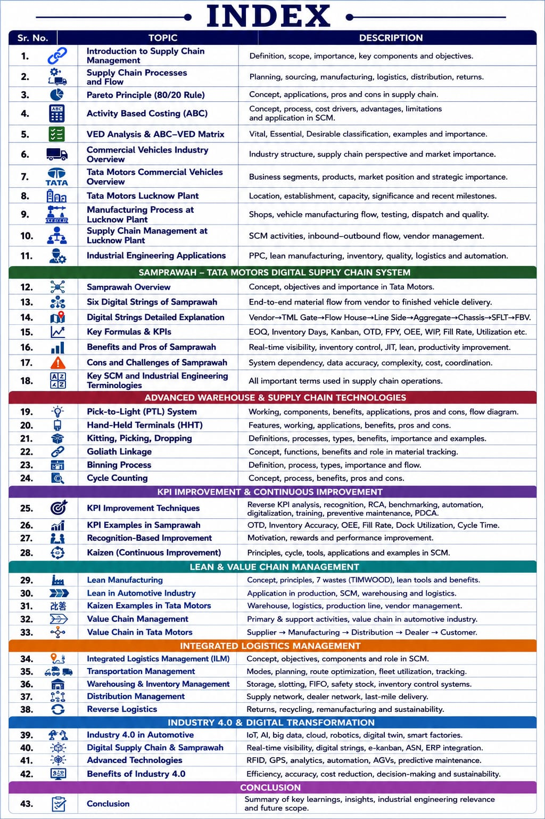INTRODUCTION
Introduction to Supply Chain:
Definition and Overview: A supply chain is an interconnected and synchronized system of all related organizations, personnel, resources, processes, information, and technology involved in the production and successful delivery of a finished product to the end user, including the moving of the product throughout the whole chain from the very beginning of the supply of the raw materials.

Key Components of Supply Chain:
1)Suppliers: The starting point of the chain; they provide the raw materials or components.
2)Manufacturers: They transform these raw inputs into finished products using labour and machinery.
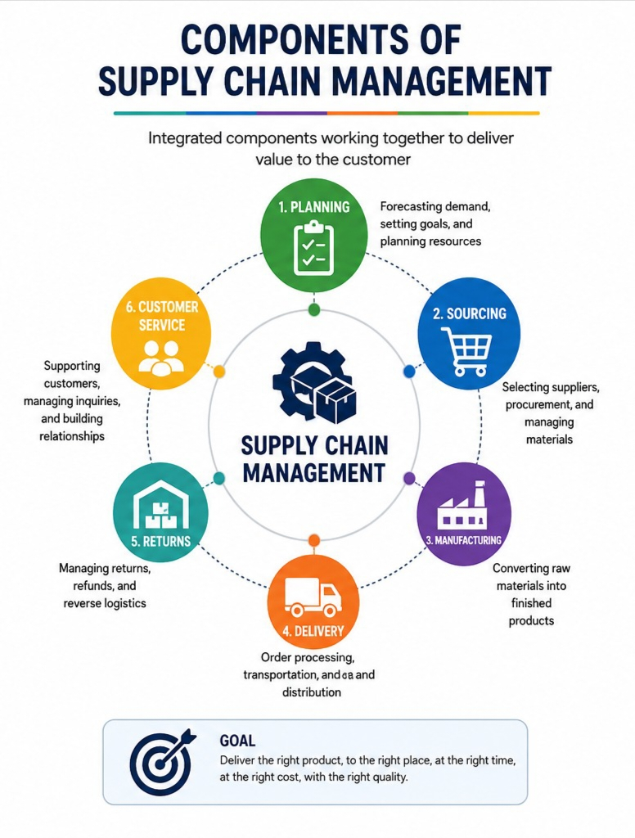3)Distributors: These intermediaries handle the logistics of moving products from manufacturers to retailers or directly to customers.
4)Retailers: Businesses that sell the products directly to the end user.
5)Customers: The final link whose demand initiates and justifies the entire process.

Importance of Supply Chain Management:

1)Cost Reduction & Increased Cash Flow: SCM reduces expenses by optimizing inventory, minimizing waste, and streamlining logistics, which in turn improves cash flow by accelerating the delivery cycle.

2)Improved Customer Service: Efficient SCM ensures accurate, timely deliveries, which increases customer satisfaction and loyalty.

3)Operational Efficiency & Agility: Effective SCM improves production speed and allows companies to adapt quickly to market changes or disruptions.

4)Risk Management: Robust supply chains help identify and mitigate potential risks (e.g., natural disasters, shortages), ensuring business continuity.

5)Global Reach & Sustainability: SCM manages complex, worldwide networks, while green supply chain management helps companies adopt sustainable, environmentally friendly practices.
6) Enhanced Inventory Management:SCM helps maintain optimal inventory levels by balancing supply and demand. It reduces excess stock, storage costs, and the risk of stockouts.Techniques such as Just-in-Time (JIT) improve inventory efficiency.
7) Better Supplier Relationship:Effective SCM fosters strong collaboration and communication with suppliers. Long-term partnerships improve quality, reliability, and cost-effectiveness. Strong supplier networks ensure uninterrupted material availability.

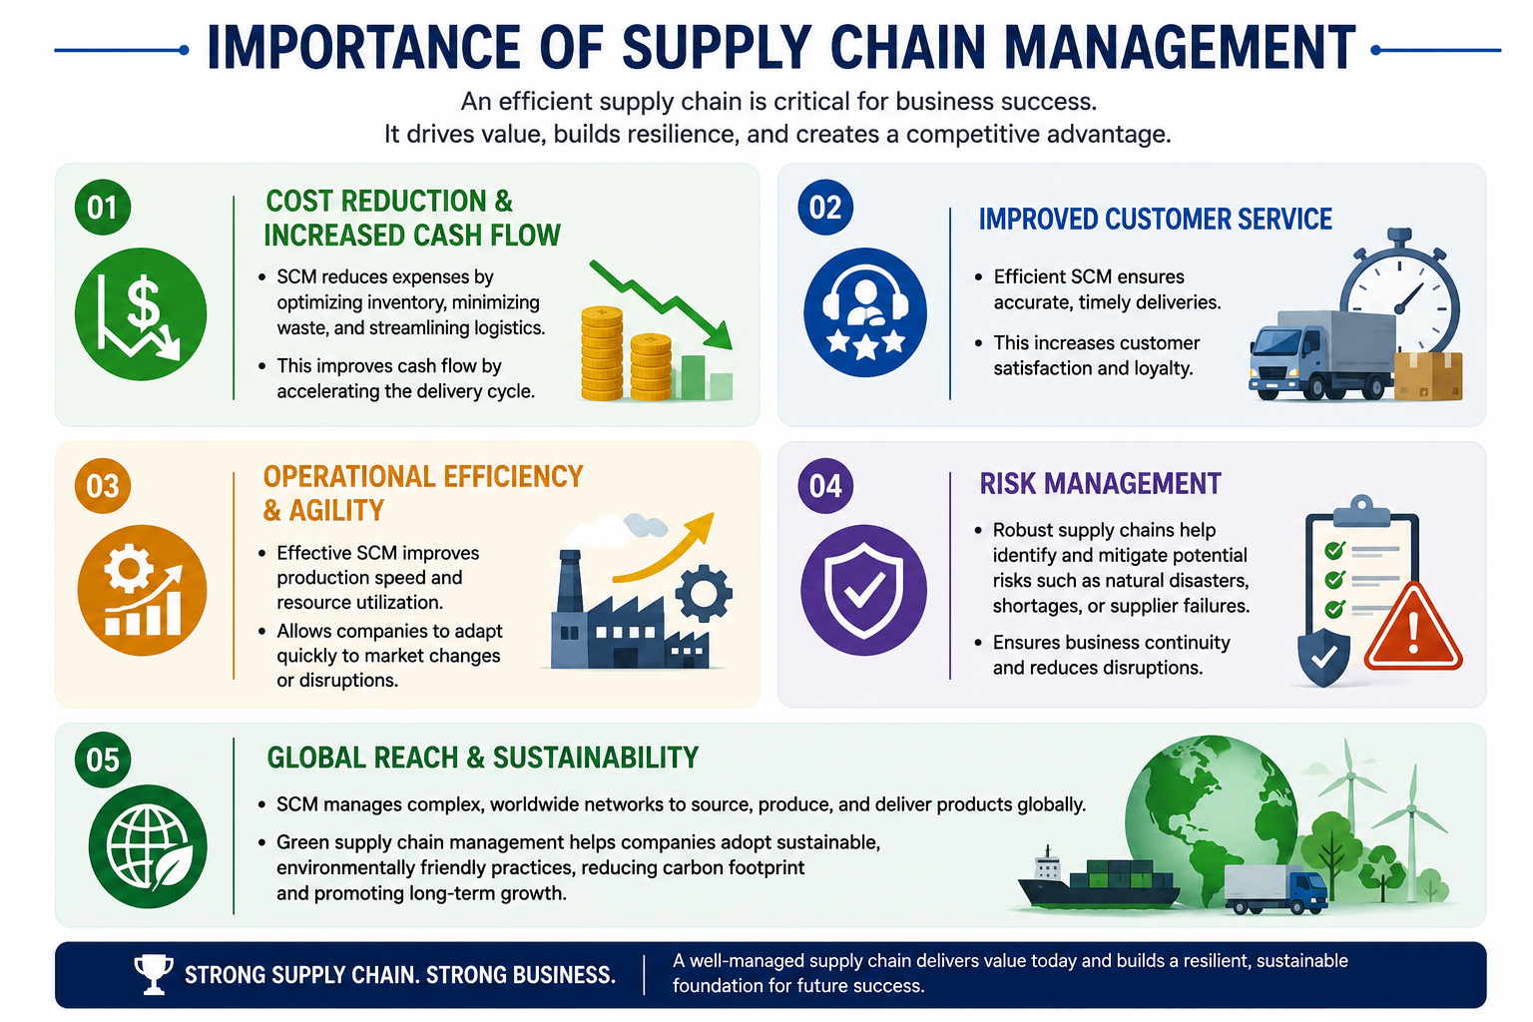
8) Competitive Advantage:Companies with efficient supply chains can deliver products faster and at lower costs than competitors.This improves market responsiveness and strengthens brand reputation. SCM becomes a strategic tool for gaining customer preference.

9)Improved Decision-Making Through Data Analytics:Modern SCM uses real-time data, AI, and analytics for forecasting and planning.Managers can make informed decisions regarding production, procurement, and distribution. Data-driven SCM reduces uncertainty and improves accuracy.

10) Increased Profitability and Business Growth:By reducing operational costs and improving customer satisfaction, SCM directly increases profitability.Efficient supply chains enable businesses to expand into new markets and scale operations effectively. Growth becomes sustainable due to better resource utilization.

Supply Chain Processes:
Efficient management requires several interconnected stages:

1)Planning: Using data and forecasting to ensure supply meets expected customer demand.
2)Sourcing: Identifying and procure materials at the right cost and quality.
3)Manufacturing: The actual production phase where quality control and efficiency are prioritized.
4)Delivery: Managing transportation and warehousing to ensure products reach their destination on time.
5)Returns: This process handles product returns, recycling and disposal . Efficient returns management helps maintain customer satisfaction and supports sustainability efforts.
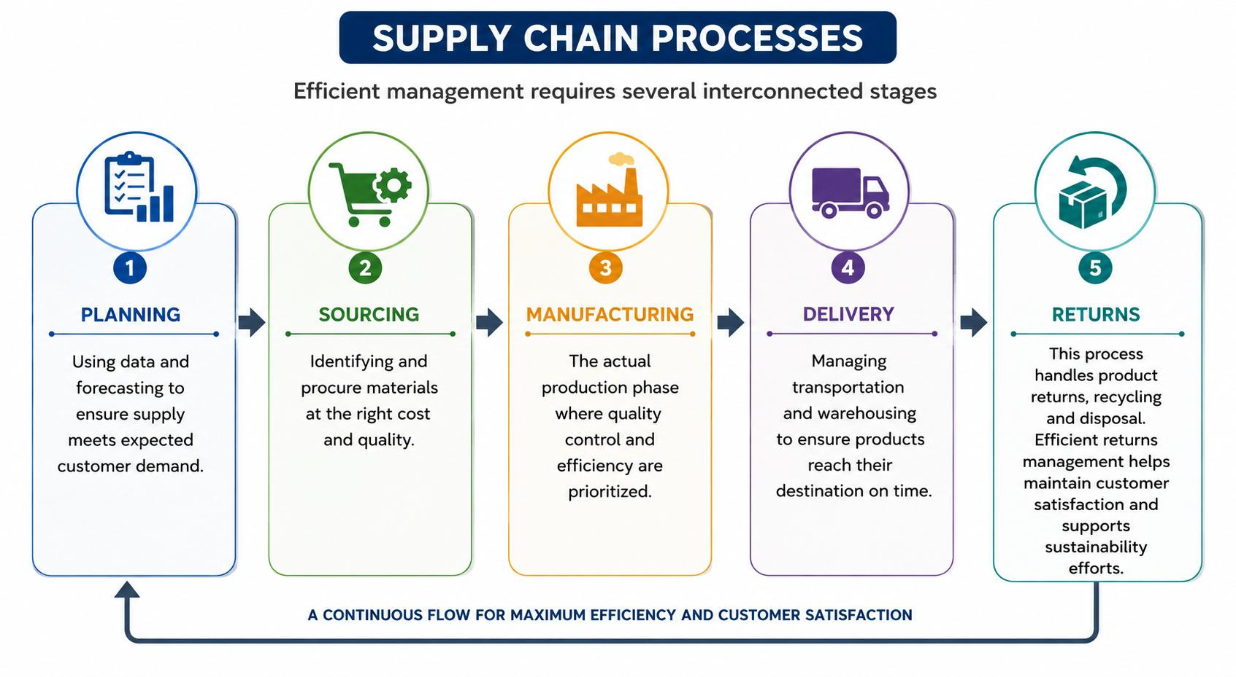

Supply Chain Flow:
Supply chain refers to the movement of materials,information,and finances from suppliers to manufacturers,distributors,retailers,and finally to customers ,ensuring product are delivered efficiently and on time.
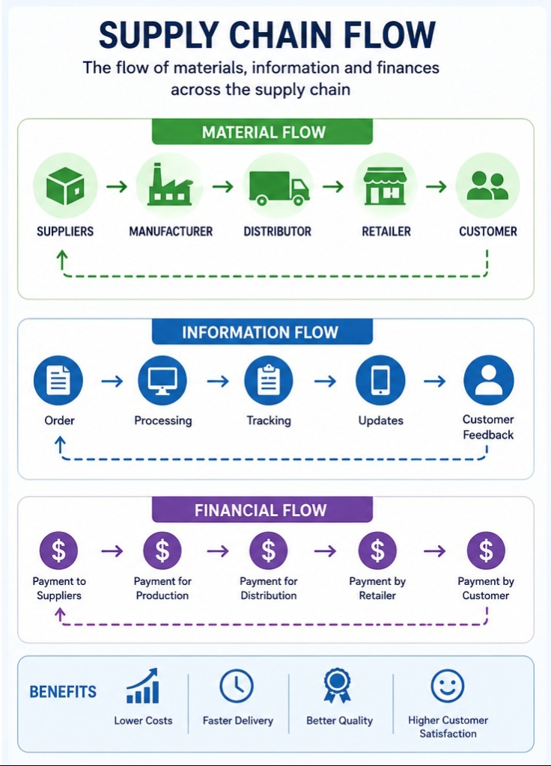

Pareto Principle (80/20 Rule) in Supply Chain Management
The Pareto Principle states that approximately 80% of outcomes come from 20% of causes. In Supply Chain Management, this concept helps organizations focus on the few factors that create the greatest impact.
Pareto principle was first observed by Italian economist Vilfredo Pareto in 1896 when he noted that 80% of Italy’s land was owned by 20% of the people.Pareto analyzed wealth distribution in Italy and found this unequal pattern.He further solidified his observations by applying it to his garden,noticing that 20% of his peapods produced 80% of the peas.
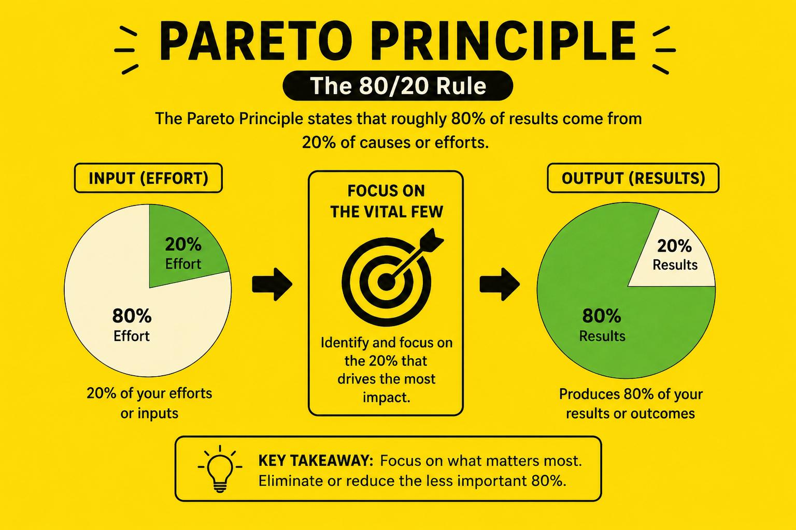
Key Applications:
Inventory Management – Around 20% of SKUs often account for 80% of total inventory value (basis of ABC Analysis).
Supplier Management – A small percentage of suppliers may contribute the majority of procurement spend or critical materials.
Customer Analysis – Approximately 20% of customers can generate 80% of revenue.
Quality Improvement – Most defects or disruptions often originate from a limited number of root causes.
Transportation & Logistics – A small number of routes or products may account for the majority of logistics costs.
Benefits of Pareto Principle
• Increased supply chain efficiency by concentrating resources on areas that deliver the greatest value.
•By identifying and prioritizing the “vital few” rather than the “trivial many,” organizations can achieve significant improvements in performance, cost optimization, and customer satisfaction.

• Improved inventory control through effective prioritization of critical stock items
•Better resource allocation by focusing efforts on high-impact products, suppliers, and processes.

Benefits of Pareto Principle

• Enhanced decision-making through data-driven identification of key performance factors.

• Reduced operational costs by addressing the major cost drivers within the supply chain.

Pros of Pareto Analysis
- Helps identify the most important issues, products, or customers that have the greatest impact.
- Improves resource allocation by focusing efforts on high-priority areas.
- Enhances decision-making and increases overall operational efficiency.

Cons of Pareto Analysis
- Depends on accurate and reliable data for effective results.
- May overlook smaller issues that can become significant over time.
- Does not identify the root cause of problems; it only highlights priorities.

ACTIVITY BASED COSTING(ABC) IN SUPPLY CHAIN MANAGEMENT
Relevance to Tata Motors Samprawah and Production & Industrial Engineering

What is Activity-Based Costing (ABC)?

Definition
Activity-Based Costing (ABC) is a costing method that assigns costs to products, services, or processes based on the activities that consume resources.
Unlike traditional costing, ABC identifies the actual cost of each supply chain activity and allocates costs more accurately.

Simple Meaning
Instead of saying:
“Transportation cost is ₹10 lakh.”
ABC asks:
“How much cost is generated by unloading, warehousing, material handling, inspection, transportation, and dispatch individually?”

Why ABC is Important in Supply Chain Management?
Supply chains involve numerous activities:
- Purchasing
- Transportation
- Receiving
- Warehousing
- Material Handling
- Inventory Management
- Production Support
- Quality Inspection
- Dispatch

ABC Costing Process

Step 1: Identify Activities
Examples:

Activity | Department
Supplier Coordination | Procurement
 | Warehouse
  Truck Unloading
Material Handling | Stores
Quality Inspection | QA
Assembly Support | Production
Vehicle loading | Dispatch

Step 2: Determine Activity Costs
Example:
Activity | Annual Cost
Unloading | ₹2,00,000
Inspection | ₹1,50,000
Material Handling | ₹3,00,000
Dispatch | ₹2,50,000

Step 3: Identify Cost Drivers
Cost Driver = Factor causing the cost.

Activity | Cost Driver
Unloading | Number of Trucks
Material Handling | Number of Parts
Inspection | Number of Material Movements
Dispatch | Number of Vehicles Shipped

Step 4: Calculate Cost Driver Rate
Formula:
Cost Driver Rate = Total Activity Cost ÷ Total Cost Driver Units

Numerical Example

Material Handling Activity
Annual Material Handling Cost
= ₹5,00,000
Material Movements
= 10,000 movements
Cost Driver Rate
= 5,00,000 ÷ 10,000
= ₹50 per movement
If a component requires:
20 material movements
Cost allocated:76=
20 × 50
= ₹1000
Thus,
ABC shows actual cost consumed by that component.

Application of ABC in Samprawah’s Six Digital Strings

Vendor → TML Gate

Activities
- Supplier Coordination
- Order Processing
- Transportation

Cost Drivers
- Number of Purchase Orders
- Number of Trucks

ABC Benefit
- Supplier-wise logistics cost analysis

TML Gate → Flow House

Activities
- Unloading
- Inspection
- Put-Away

Cost Drivers
- Trucks Received
- Material Volume

ABC Benefit
- Warehouse cost optimization

Flow House → Line Side

Activities
- Picking
- Kitting
- Internal Transportation

Cost Drivers
- Number of Kits
- Number of Replenishments

ABC Benefit
- Improved line feeding efficiency

Aggregate Shop → Chassis Line

Activities
- Subassembly Production
- Material Issue
- WIP Handling

Cost Drivers
- Production Orders
- WIP Quantity

ABC Benefit
- Reduced manufacturing waste

Chassis Line → SFLT

Activities
- Assembly
- Inspection
- Rework

Cost Drivers
- Number of Vehicles
- Defects Found

ABC Benefit
- Quality cost analysis

TML Gate → FBV

Activities
- Vehicle Storage
- Loading
- Transportation

Cost Drivers
- Number of Vehicles Dispatched

ABC Benefit
- Logistics cost optimization

Traditional Costing vs Activity-Based Costing
Traditional Costing | Activity-Based Costing
Allocates cost broadly | Allocates cost accurately
Less precise | Highly precise
Focuses on departments | Focuses on activities
May hide inefficiencies | Identifies waste
Suitable for simple systems | Suitable for complex supply chains

Benefits/Pros of ABC for Production & Industrial Engineers
1)Cost Visibility
Identifies exact cost of:

2)Lean Manufacturing
Helps eliminate:
- Waiting
- Excess movement
- Excess inventory

Process Improvement
- Identifies bottlenecks and costly operations.
- Better Decision Making
Supports:

Real-Life Example at Tata Motors
- Suppose:
- Annual Logistics Cost
- = ₹1 Crore
- ABC analysis shows:

Activity | Cost
Transportation | ₹40 Lakh
Warehousing | ₹20 Lakh
Material Handling | ₹25 Lakh
Inspection | ₹10 Lakh
Administration | ₹5 Lakh

Management discovers:
Material Handling Cost = 25%
Decision:
Introduce AGVs (Automated Guided Vehicles)
Result:
Material Handling Cost reduced by 20%
Annual Savings:
₹5 Lakh
Cons Of Activity Based Costing(ABC)

Vital,Essential,Desirable(VED)
In VED Analysis (commonly used in inventory and spare parts management), items are classified based on their criticality to operations:
Category | Full Form | Meaning | Impact if unavailable
V | vital | Extremely critical items necessary for continuous operation. | Production may stop completely.
E | Essential | Important items that affect efficiency but may not immediately stop operations. | Reduced productivity or temporary disruption.
D | Desirable | Items that are convenient but not critical for operations. | Minimal impact; work can continue without them for some time.

Example in an Automotive Plant (Tata Motors)

Vital Items
- CNC machine spindle motor
- Main conveyor motor
- PLC controller
- Critical safety sensors
Effect: Production line may shut down if unavailable.

Essential Items
- Bearings
- Hydraulic hoses
- Pneumatic valves
- Standard tooling
Effect: Production continues for some time but efficiency decreases.

Desirable Items
- Office stationery
- Additional tool kits
- Decorative fixtures
- Non-critical maintenance accessories
Effect: Little or no effect on production.

Importance in Supply Chain Management

Link with ABC Analysis
A common inventory control technique is ABC–VED Matrix Analysis, where:
- ABC classifies items by annual consumption value.
- VED classifies items by criticality.
This helps Production & Industrial Engineers prioritize procurement, inventory investment, and spare parts management in manufacturing plants.

Pros of VED Analysis (Vital, Essential, Desirable)

Cons of VED Analysis

Introduction to the Commercial Vehicles Industry from a Supply Chain Management Perspective
The commercial vehicles industry is one of the most complex and globally interconnected industries, involving the design, manufacturing, distribution, and servicing of vehicles. It contributes significantly to economic growth, employment generation, technological advancement, and infrastructure development. The industry comprises various segments, including passenger vehicles, commercial vehicles, electric vehicles, two-wheelers, and auto components.
From a Supply Chain Management (SCM) perspective, the commercial vehicles industry operates through an extensive network of suppliers, manufacturers, logistics providers, dealers, and customers. Modern vehicle manufacturing requires thousands of components sourced from multiple suppliers located across different regions and countries. Effective coordination among these stakeholders is essential to ensure uninterrupted production and timely delivery of vehicles.
The supply chain begins with raw material suppliers providing steel, aluminum, plastics, rubber, and electronic components. These materials are processed by Tier-1, Tier-2, and Tier-3 suppliers to manufacture parts and assemblies, which are then delivered to vehicle manufacturers such as Tata Motors. The manufacturers assemble these components into finished vehicles, which are distributed through warehouses and dealer networks before reaching customers.

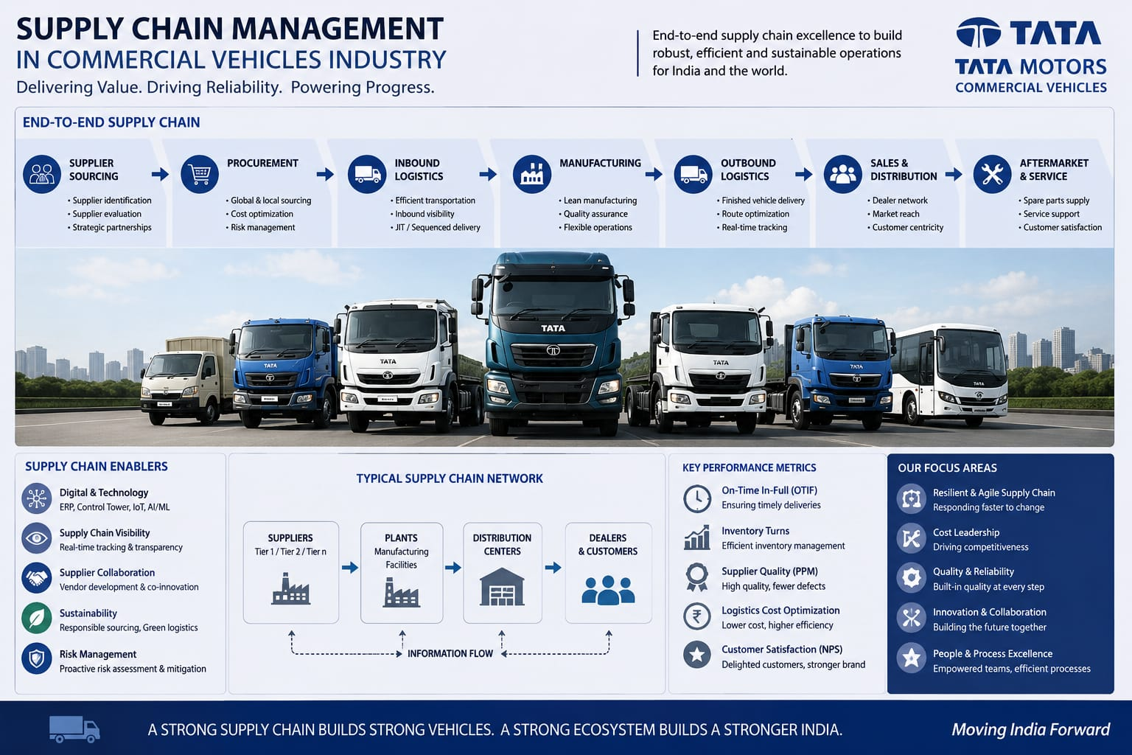
Transportation and logistics

- In the commercial vehicle sector, efficient supply chain management is particularly critical because production schedules, inventory levels, supplier coordination, and distribution networks directly influence delivery performance and business profitability. Companies such as Tata Motors rely on integrated supply chain systems to ensure the seamless flow of materials, information, and finances across their operations
- Due to increasing competition, customer expectations, and globalization, automotive companies are adopting advanced SCM practices such as Just-in-Time (JIT), Lean Manufacturing, Industry 4.0, Internet of Things (IoT), Artificial Intelligence (AI), and real-time supply chain visibility systems. These practices help reduce costs, improve operational efficiency, enhance product quality, and increase customer satisfaction

Supply Chain Management in the commercial vehicles industry focuses on:

Relevance to Industrial Engineering
- For Production and Industrial Engineers, the automotive supply chain provides opportunities to apply concepts such as:
- Production Planning and Control (PPC)
- Lean Manufacturing
- Inventory Optimization
- Logistics Management
- Facility Layout Planning
- Work Study and Time Study
- Quality Management
- Process Improvement
- Thus, Supply Chain Management serves as a strategic function that enables automotive manufacturers to achieve operational excellence, maintain competitiveness, and meet customer demands in a dynamic market environment.

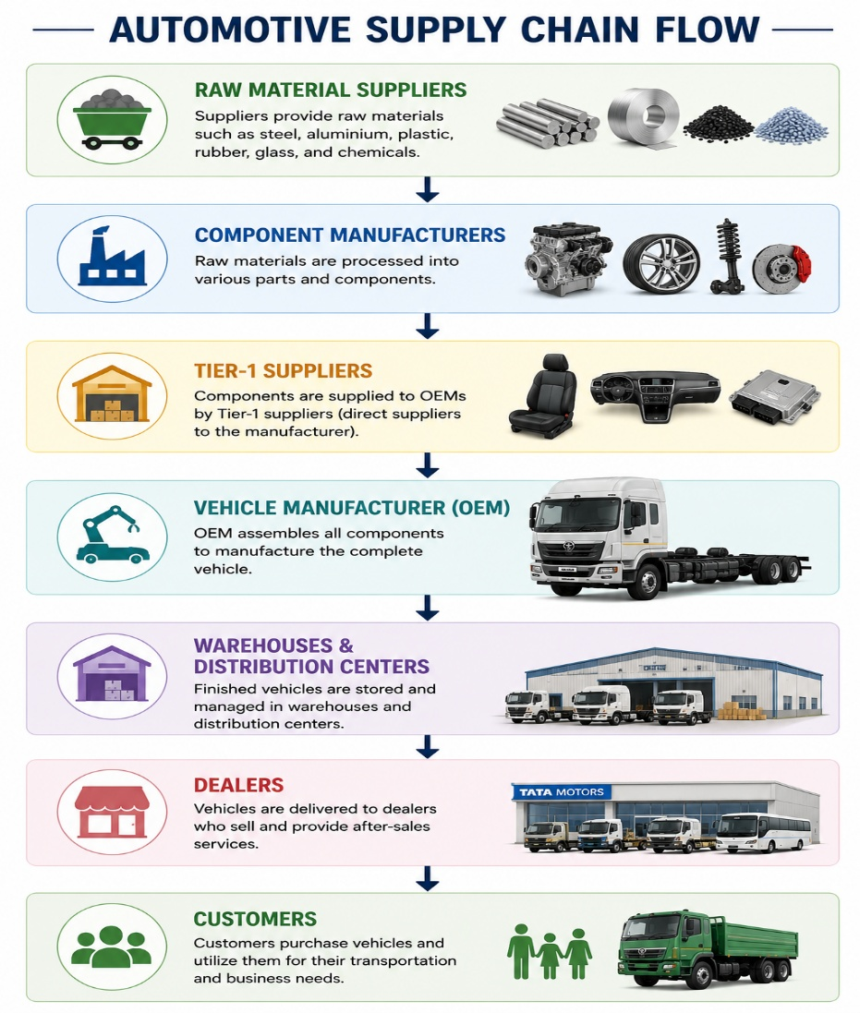

Overview of Tata Motors Commercial Vehicles:

Introduction
Tata Motors is India’s largest commercial vehicle manufacturer and one of the world’s leading producers of trucks, buses, and special-purpose vehicles. Founded in 1945, the company is a part of the Tata Group and has played a significant role in developing India’s transportation and logistics infrastructure.
The Commercial Vehicle (CV) business of Tata Motors caters to freight transportation, passenger mobility, construction, mining, defense, and municipal applications.

Commercial Vehicle Business Segments

1. Heavy Commercial Vehicles (HCV)
These vehicles are used for long-haul transportation, mining, construction, and heavy-duty logistics.
Popular Models:
  - Tata Prima Series
  - Tata Signa Series
  - Tata LPT Series
  - Tata Ultra Heavy Trucks
Applications:

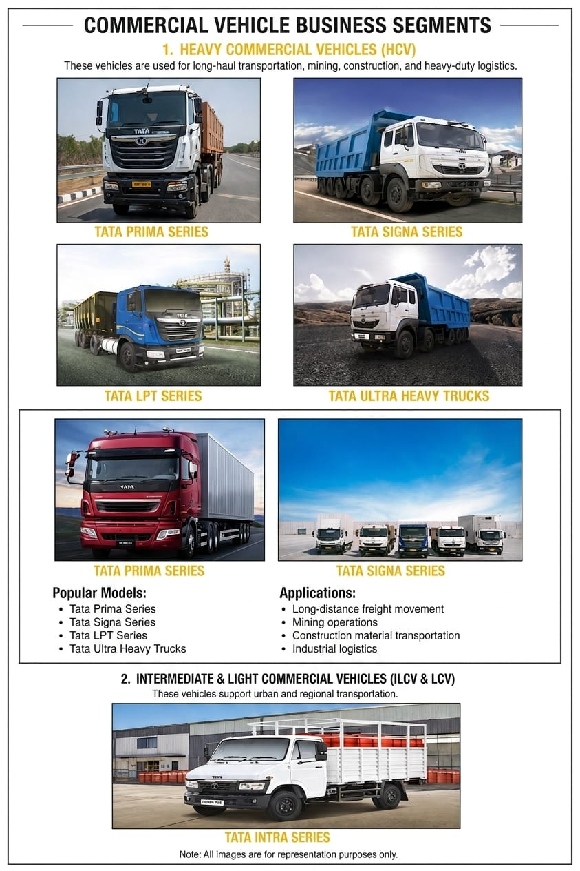

2. Intermediate & Light Commercial Vehicles (ILCV & LCV)

These vehicles support urban and regional transportation

Popular Models:
- Tata Ace (“Chhota Hathi”)
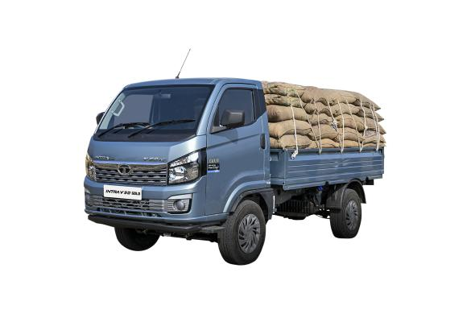
(This is Tata Ace)
- Tata Intra
- Tata Yodha
- Tata 407 Gold

Tata Ultra Series

Applications:

3. Passenger Commercial Vehicles
Tata Motors is also a major manufacturer of buses and coaches.

Categories:
- School Buses
- Staff Buses
- Intercity Coaches
- City Transit Buses
- Electric Buses

Popular Models:
- Tata Starbus
- Tata Cityride
- Tata Magna Coach
Applications include public transportation, employee transportation, tourism, and education sectors.

4. Electric Commercial Vehicles (E-CVs)
Tata Motors is a pioneer in India’s electric mobility ecosystem.

Products:
- Tata Ace EV
- Tata Ultra EV
- Electric City Buses

Advantages:

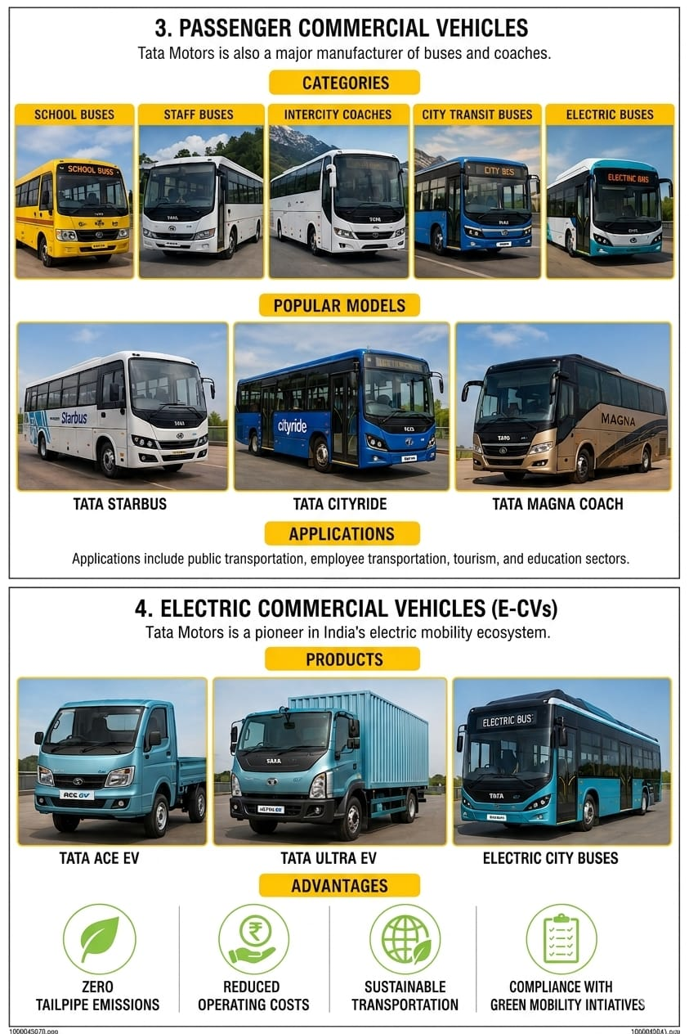

Tata Motors Lucknow Plant
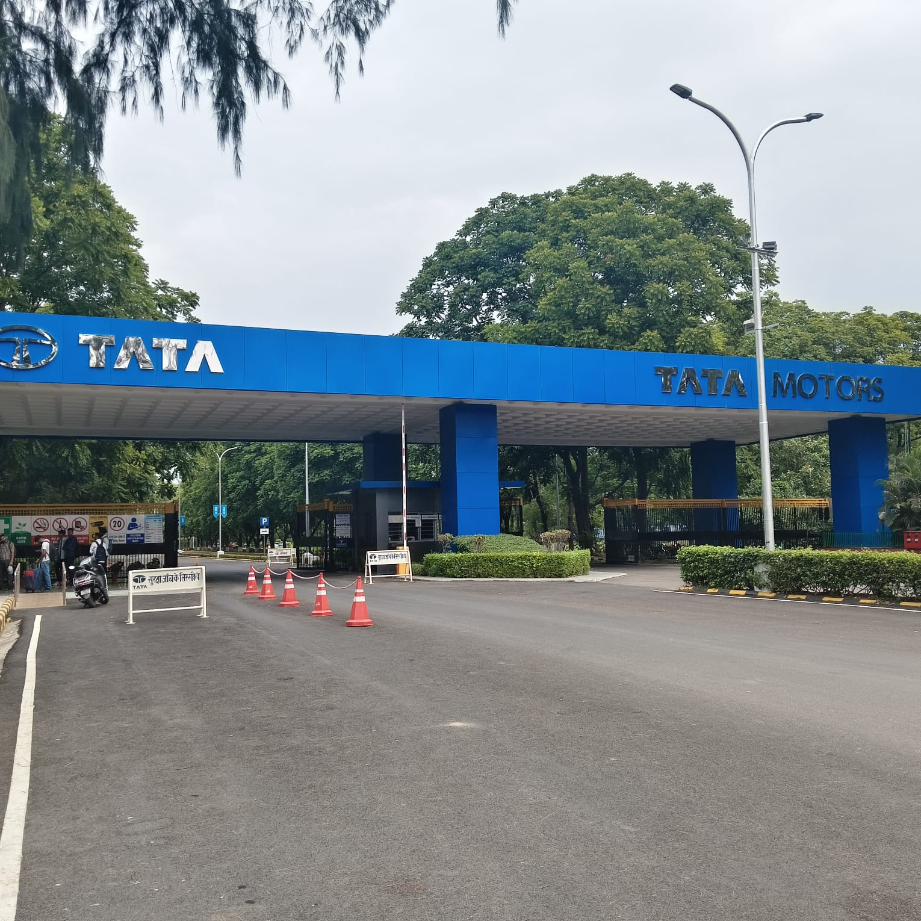
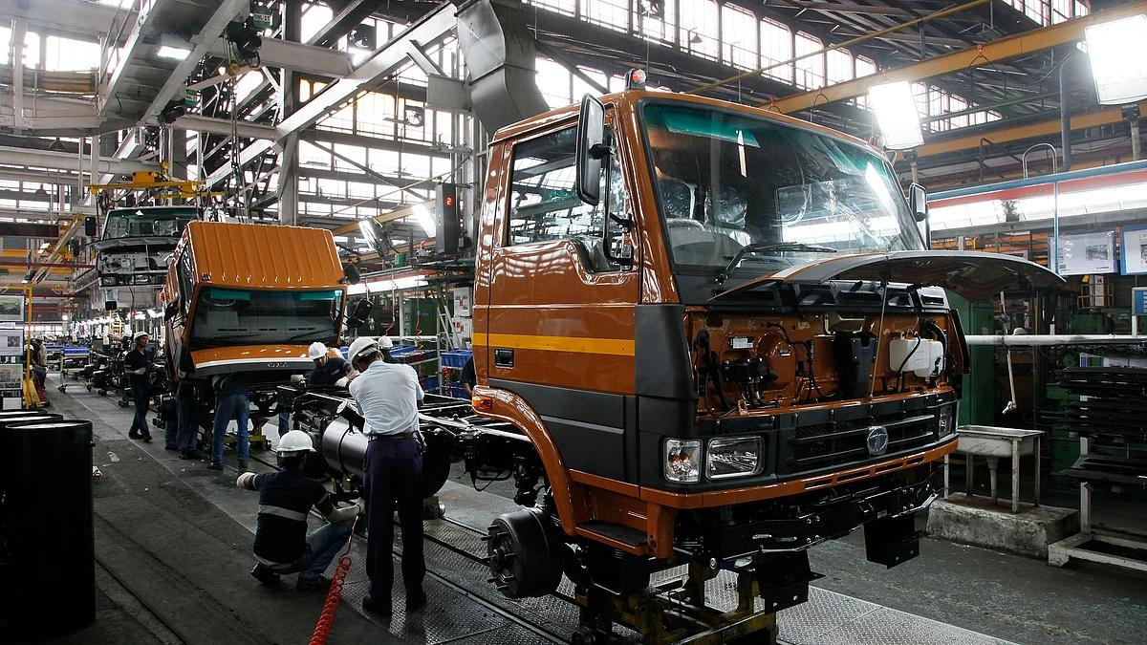

Introduction
The Tata Motors Lucknow Plant is one of the company’s most important commercial vehicle manufacturing facilities. Established in 1992, the plant was set up to cater to the growing demand for commercial vehicles in India. Over the years, it has evolved into a technologically advanced manufacturing hub producing trucks, buses, electric buses, and specialized commercial vehicles.

2. Location
- Location: Lucknow, Uttar Pradesh, India
- Manufacturer: Tata Motors
- Business Unit: Commercial Vehicles Division
- Operational Since: 1992

3. Plant Overview
The facility is among Tata Motors’ most technologically advanced manufacturing plants and serves as a major hub for commercial vehicle production.
Particular | Details
Plant Area | Approximately 600 acres
Established | 1992
Production Capacity | More than 100,000 vehicles per year
Vehicle Types | Trucks, Buses, Electric Buses, Defense Vehicles
Market Served | India and Export Markets
4. Major Products Manufactured

Commercial Trucks

Passenger Commercial Vehicles

Green Mobility Solutions

Specialized Vehicles

The Lucknow facility is particularly known for bus manufacturing and fully built vehicle production.

5. Manufacturing Process

Vehicle Manufacturing Flow

Raw Material
↓

Fabrication Shop
↓

Body Shop
↓

Paint Shop
↓

Assembly Line
↓

Quality Inspection
↓

Vehicle Testing
↓
Dispatch

Key Shops

Body Shop
- Welding operations
- Chassis fabrication
- Structural assembly

Paint Shop
- Surface preparation
- Primer coating
- Final painting
- Corrosion protection

Assembly Shop
- Engine installation
- Transmission assembly
- Electrical systems integration
- Interior fitment

Testing & Quality
- Functional testing
- Road testing
- Safety inspection

6.)Supply Chain Management at Lucknow Plant

Supply Chain Flow
Suppliers
↓
Inbound Logistics
↓
Warehouse
↓
Production Lines
↓
Finished Vehicle Yard
↓
Dealers
↓
Customers

SCM Activities
- Procurement Management
- Vendor Development
- Inventory Control
- Material Requirement Planning (MRP)
- Logistics Management
- Distribution Planning
- After-Sales Support

7. Industrial Engineering Applications
As a Production & Industrial Engineering student, focus on:

Production Planning and Control (PPC)
- Demand forecasting
- Production scheduling
- Capacity planning

Lean Manufacturing

Industrial Engineering Applications

- As a Production and Industrial Engineering student, the Tata Motors Lucknow plant provides valuable insights into modern manufacturing and operations management. The plant demonstrates effective Production Planning and Control (PPC) through demand forecasting, production scheduling, and capacity planning to ensure smooth and efficient operations. Lean Manufacturing practices such as 5S, Kaizen, waste reduction, and continuous improvement help enhance productivity and operational excellence. Work Study techniques, including method study, time study, and productivity analysis, are applied to optimize processes and resource utilization. The plant also emphasizes Inventory Management through material flow optimization, stock control, and warehouse management systems. Strong Quality Management practices, including Total Quality Management (TQM), Root Cause Analysis (RCA), and process improvement initiatives, ensure high product quality and reliability. Furthermore, the plant has embraced Industry 4.0 and Automation by integrating robotic spot welding, robotic paint systems, automated manufacturing operations, AI-enabled digital platforms, and digital production monitoring systems. These advanced technologies significantly improve product quality, productivity, workplace safety, and overall operational efficiency, making the facility a model of modern industrial manufacturing.

9. Sustainability Initiatives
Tata Motors’ sustainability initiatives focus on reducing environmental impact while promoting responsible manufacturing practices. The plant operates as a water-positive facility, replenishing more water than it consumes and supporting efficient water management. It utilizes 100% renewable electricity for its operations, significantly reducing carbon emissions and dependence on conventional energy sources. Solar power generation further strengthens the plant’s commitment to clean energy. Waste reduction initiatives, including recycling, reuse, and efficient resource utilization, help minimize environmental footprint. Through the adoption of green manufacturing practices, the facility enhances operational efficiency while contributing to Tata Motors’ broader sustainability objectives and long-term environmental stewardship.

10. Recent Milestones

The Tata Motors Lucknow plant achieved a significant milestone in April 2026 with the rollout of its 10 lakhth commercial vehicle. Notably, the milestone vehicle was a zero-emission electric bus, reflecting the company’s strong commitment to sustainable and future-ready mobility solutions. With over 30 years of manufacturing excellence, the plant has established itself as a key hub for commercial vehicle production in India. It supports more than 8,000 livelihoods directly and indirectly while fostering a robust supplier and MSME ecosystem. The facility also possesses export-oriented production capabilities and continues to play a vital role in driving industrial development and economic growth in Uttar Pradesh.
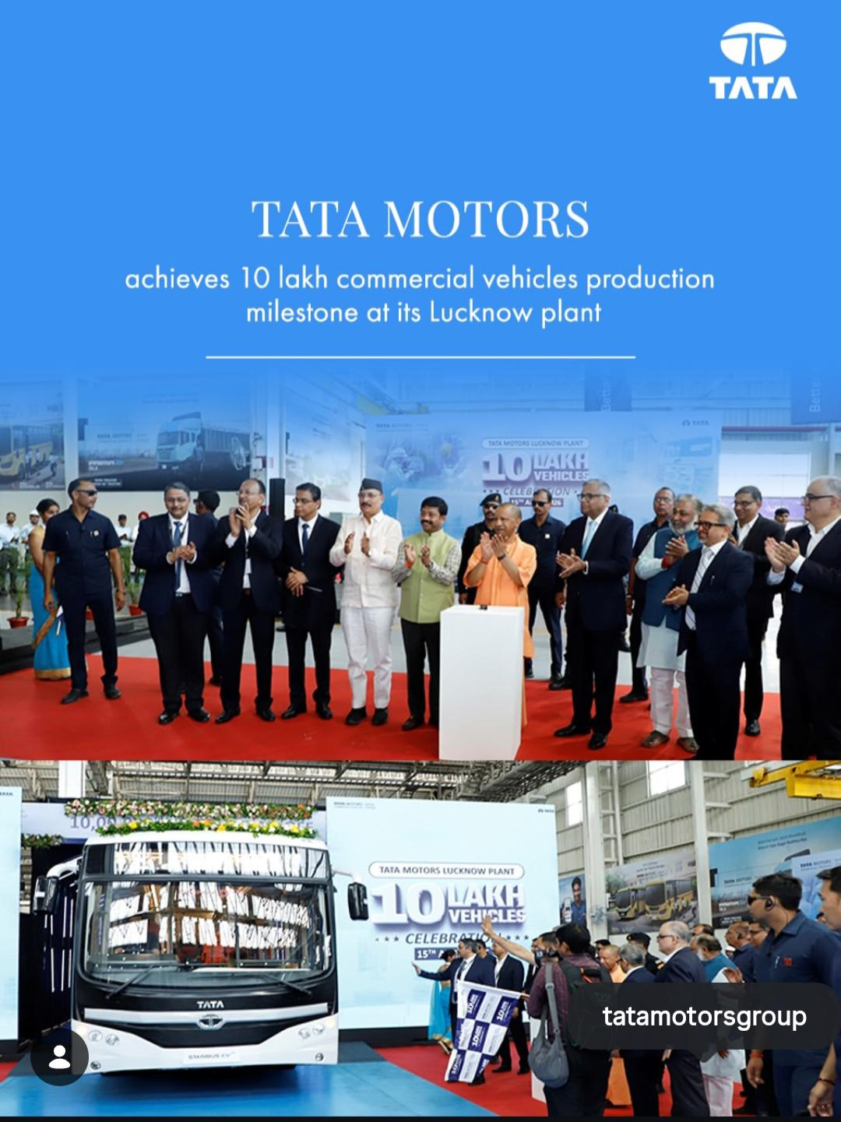

Supply Chain and Manufacturing Network
Tata Motors operates a vast manufacturing and supply chain network across India.

Major Manufacturing Plants

Jamshedpur Plant
- Largest CV manufacturing facility.
- Produces trucks and buses.

Pune Plant
- Manufactures commercial and passenger vehicles.

Lucknow Plant
- Specializes in buses and defense vehicles.
- Important hub for customization and assembly.

Supply Chain Structure

Key SCM functions:

Technological Innovations
Tata Motors incorporates Industry 4.0 technologies:

IoT-enabled fleet
monitoring

Digital supply chain management

Predictive maintenance

Technological Innovations

Connected vehicles solutions

AI-based diagnostics

Telematics systems

The company’s fleet management platform, Fleet Edge, provides:
- Vehicle health monitoring
- Fuel efficiency analysis
- Driver behavior tracking
- Real-time location tracking

Sustainability Initiatives
Tata Motors focuses on:
- Green manufacturing
- Electric mobility
- Circular economy practices
- Carbon footprint reduction
- Waste minimization
- Renewable energy integration
These initiatives align with global ESG (Environmental, Social, and Governance) goals.
Importance for Industrial Engineering & Supply Chain Management
For an Industrial Engineering intern, Tata Motors provides exposure to:

Production Engineering
- Assembly line operations
- Lean manufacturing
- Quality control
- Kaizen implementation

Supply Chain Management
- Vendor management
- Material Requirement Planning (MRP)
- Inventory optimization
- Logistics coordination

Operations Management
- Capacity planning
- Resource utilization
- Productivity improvement
- Process optimization

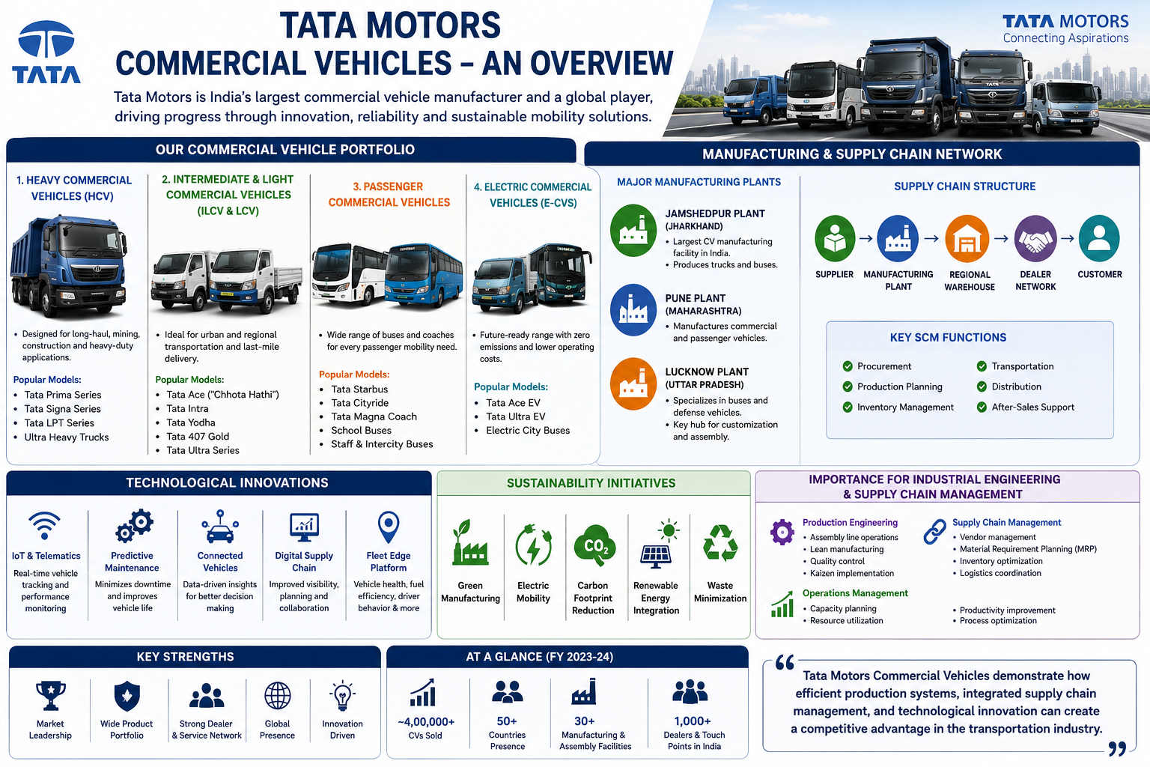

Objectives of the Study

Primary Objective
To study the manufacturing operations, production planning systems, and supply chain management practices of Tata Motors Commercial Vehicles from a Production and Industrial Engineering perspective.

Specific Objectives
From a Production and Industrial Engineering perspective, the Tata Motors Lucknow Plant serves as an excellent example of how modern manufacturing systems integrate operational excellence with advanced technology. The plant follows a structured Production Planning and Control (PPC) framework that enables efficient demand forecasting, production scheduling, and capacity planning, ensuring that customer requirements are met while maintaining optimal utilization of resources. These practices contribute significantly to maintaining production continuity and minimizing operational bottlenecks.
The facility's operational philosophy is strongly aligned with Lean Manufacturing principles, focusing on continuous improvement and waste elimination. Key lean practices observed include:
• 5S workplace organization
• Kaizen-based continuous improvement initiatives
• Waste reduction and process optimization
• Employee involvement in productivity enhancement
In addition, the plant applies various Work Study techniques to improve efficiency and resource utilization. Method study and time study are used to analyze workflows, eliminate non-value-added activities, and enhance overall productivity. These practices help in achieving standardized operations and improved process performance.
Efficient inventory and material management form another critical aspect of the plant's operations. The facility emphasizes smooth material flow and inventory control through:
• Optimized material handling systems
• Effective stock control mechanisms
• Systematic warehouse management practices
• Reduced inventory-related losses and delays
Quality management is deeply embedded across all stages of manufacturing. The plant adopts a preventive approach to quality through Total Quality Management (TQM), Root Cause Analysis (RCA), and continuous process improvement initiatives. This ensures high product reliability, reduced defects, and enhanced customer satisfaction.
A particularly noteworthy aspect of the facility is its adoption of Industry 4.0 and smart manufacturing technologies. Automation and digitalization play a crucial role in enhancing manufacturing performance through:
• Robotic spot welding systems
• Robotic paint shop operations
• AI-enabled digital platforms
• Real-time production monitoring systems
• Automated manufacturing processes
The integration of these technologies has significantly improved product quality, operational efficiency, workplace safety, and production consistency. By combining lean manufacturing principles, advanced automation, robust quality systems, and data-driven decision-making, the Tata Motors Lucknow Plant represents a benchmark for modern automotive manufacturing and offers valuable learning opportunities for Production and Industrial Engineering professionals.

SAMPRAWAH
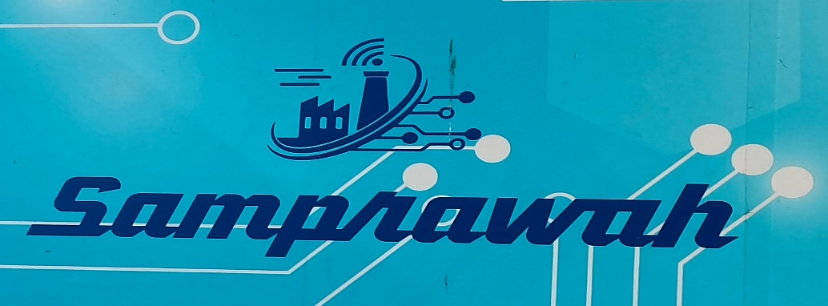
Samprawah is a smart kitting or line replenishment process
In many Tata Motors supply-chain discussions, work is broadly organized around areas such as:
1)Supplier/Vendor Management
2)Procurement & Purchase Orders
3)Logistics &Transportation
4)Inventory & Material Planning
5)Production/Assembly Coordination
6)Invoicing & Payment/Reconciliation


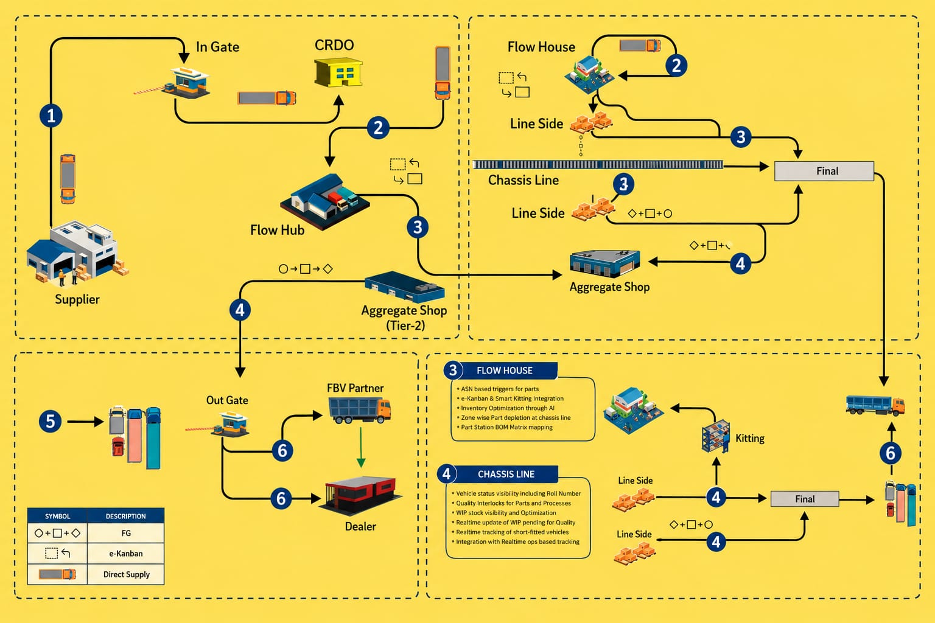

Integrated Flow and Management

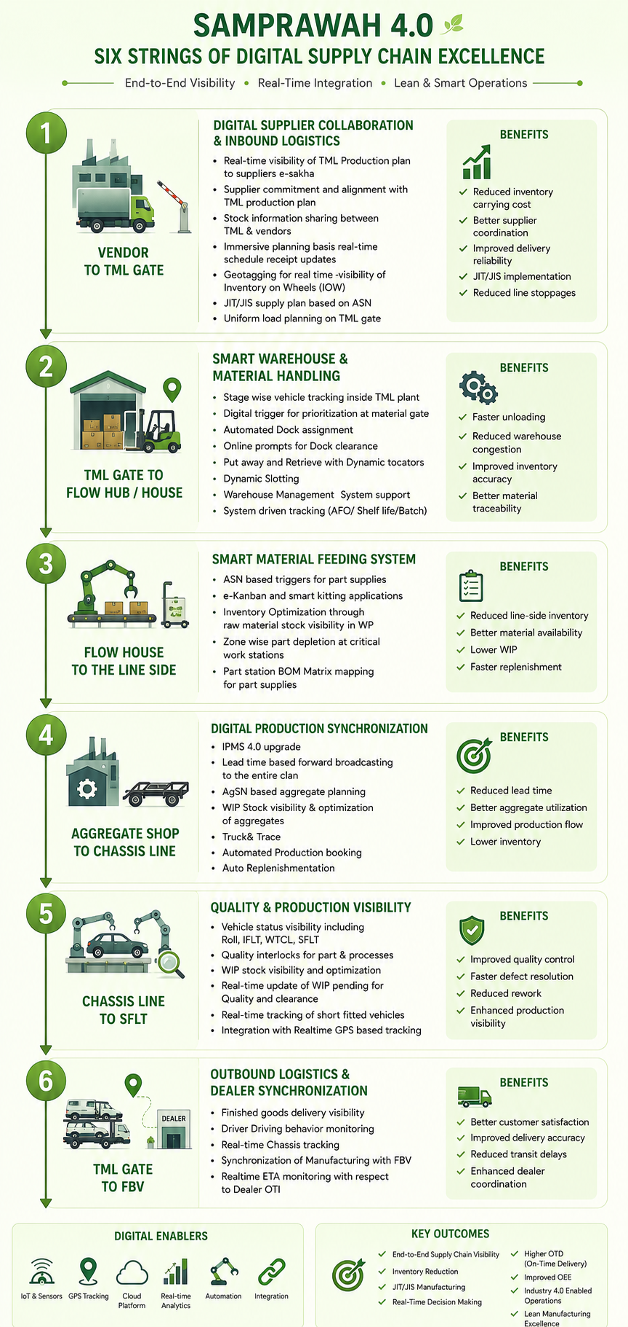
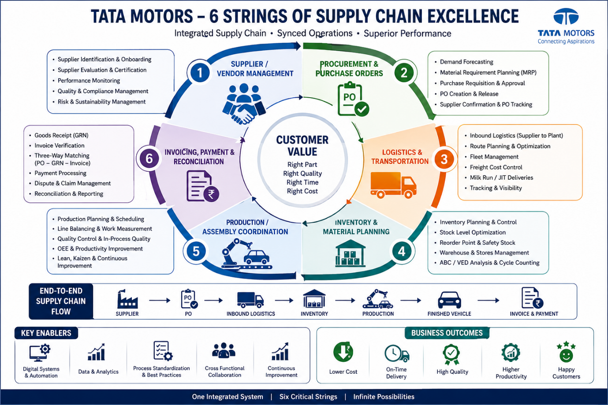

SAMPRAWAH – DIGITAL MATERIAL STRINGS
Relevance to Production & Industrial Engineering in Supply Chain Management
(Tata Motors Manufacturing System Perspective)
The six digital strings of Samprawah create an end-to-end digital thread connecting suppliers, warehouses, production shops, assembly lines, and vehicle dispatch. For a Production & Industrial Engineer, these strings are directly related to:
- Production Planning & Control (PPC)
- Inventory Management
- Material Requirement Planning (MRP)
- Lean Manufacturing
- JIT/JIS Supply
- Warehouse Management
- Logistics Optimization
- Line Balancing
- Work-in-Progress (WIP) Control
- Industry 4.0 & Smart Manufacturing

Production Schedule
Synchronization

Transport Optimization
Supplier Coordination
Industrial Engineering Relevance &
Responsibilities

Material availability Inventory Visibility
assurance

Key Concepts
Economic Order Quantity (EOQ)
EOQ= √[(2DS)/H]
Where:
D = Annual Demand
S = Ordering Cost
H = Holding Cost

Numerical Example
Demand = 50,000 units/year
Ordering Cost = ₹1000/order
Holding Cost = ₹20/unit/year
EOQ = √[(2×50000×1000)/20]
EOQ = 2236 units
Meaning:
The supplier should ideally dispatch 2236 units per shipment.

Inventory Days Formula

Inventory Days = Inventory / Daily Consumption
Example:
Inventory = 600 units
Daily Consumption = 120 units
Inventory Days = 600/120 = 5 Days

Industrial Engineers ensure optimal inventory levels by preventing stockouts and minimizing excess inventory. They use demand forecasting and inventory control techniques to maintain material availability for uninterrupted production. This helps reduce carrying costs, improve resource utilization, and enhance overall operational efficiency.

Benefits

2.TML GATE TO FLOW HUB/HOUSE
(Material Storage & Warehousing)
Industrial Engineering Relevance
Responsibilities
- Dock scheduling
- Warehouse optimization
- Dynamic slotting
- FIFO implementation
Warehouse Utilization

Warehouse Utilization (%) =
(Storage Used / Total Storage Capacity) ×100
Numerical
Used Area = 8000 sq.m
Total Area = 10000 sq.m
Utilization
= (8000/10000)×100
= 80%
Dock Efficiency

Dock Efficiency (%) =

Actual Dock Usage / Available Dock Time ×100
Example:
Available = 10 hrs
Used = 8 hrs
Efficiency = 80%

Benefits

3. FLOW HOUSE TO LINE SIDE
(Material Feeding to Production Line)
Industrial Engineering Relevance
Responsibilities
- e-Kanban implementation
- Smart kitting
- Line-side inventory control
- Part replenishment

Kanban Formula
N=D×L×(1+S)C
Where
N = Number of Kanbans
D = Daily Demand
L = Lead Time
S = Safety Factor
C = Container Size

Numerical
Demand = 500 parts/day
Lead Time = 2 days
Safety Factor = 20%
Container = 50 parts
N= (500×2×1.2)/50
N= 24 Kanbans

Benefits

4.AGGREGATE SHOP TO CHASSIS LINE
(Sub-Assembly Production Control)
Industrial Engineering Relevance

Responsibilities

Examples:
- Engine assembly
- Transmission assembly
- Axle assembly

Little’s Law
Little’s Law is used in supply chain management(SCM) to relate Work-in-progress(WIP),Throughput ,and lead Time.
Where,
- WIP(Work in Progress)=Average number of units/items in the system
- Throughput Rate=Number of units completed per unit time
- Lead Time=Average time a unit spends in the system

WIP Formula

WIP = Throughput × Lead Time
(Little’s Law)
Numerical
Throughput = 100 units/day
Lead Time = 3 days
WIP
= 100 × 3
= 300 units

Production Efficiency

Efficiency (%) =

Actual Output / Planned Output ×100
Example
Actual = 850
Planned = 1000
Efficiency = 85%

Benefits
- Reduced bottlenecks
- Better aggregate visibility
- Improved production planning
- Defect tracking

5.) CHASSIS LINE TO SFLT
(Final Assembly & Quality Tracking)
Industrial Engineering Relevance
Responsibilities are as follows:

First Pass Yield (FPY)

FPY (%) =

Good Units / Total Units ×100

Numerical
Produced = 1000
Passed First Time = 950
FPY = 95%

Rework Percentage
Rework % =
Reworked Units / Total Units ×100
Example
50/1000 ×100
= 5%

Benefits:

6.TML GATE TO FBV
(Finished Vehicle Logistics)
Industrial Engineering Relevance
Responsibilities
- Vehicle dispatch planning
- Fleet utilization
- GPS tracking
- ETA prediction

Transportation Utilization
Vehicle Utilization (%) =
Actual Load / Maximum Capacity ×100
Numerical
Truck Capacity = 10 vehicles
Loaded = 8 vehicles
Utilization
= 8/10 ×100
= 80%

On-Time Delivery (OTD)

OTD (%) =
On-Time Deliveries / Total Deliveries ×100
Numerical
On-Time = 480
Total = 500
OTD = 96%

Benefits
- Improved dealer satisfaction
- Reduced logistics cost
- Better delivery performance
 | Formula
  KPI
 | Annual Consumption / Average Inventory
  Inventory Turnover
Overall Equipment Effectiveness(OEE) | Availability × Performance × Quality
Fill Rate | Orders Fulfilled / Total Orders
Service Level | Orders Delivered On Time / Total Orders
Dock Utilization | Dock Used / Dock Available
Line Efficiency | Actual Output / Planned Output
Work In Progress (or Work In Process) | Throughput × Lead Time
Economic Order Quantity | √[(2DS)/H]
Kanban Quantity | D×L×(1+S)/C
On-Time Delivery | On-Time Deliveries / Total Deliveries

Samprawah provides an integrated digital material flow from supplier to finished vehicle delivery. It enables real-time visibility of inventory, WIP, production schedules, warehouse operations, logistics movement, and vehicle dispatch. A Production & Industrial Engineer uses this data for production planning, inventory optimization, line balancing, bottleneck reduction, lean manufacturing, quality improvement, and supply chain efficiency enhancement. It supports Industry 4.0 principles by connecting suppliers, warehouses, manufacturing shops, assembly lines, and logistics into one digital ecosystem.
The six digital strings of Samprawah form a complete digital supply chain backbone of Tata Motors. They ensure seamless material flow, real-time visibility, inventory optimization, lean manufacturing, WIP control, quality assurance, and efficient finished vehicle delivery. For a Production & Industrial Engineer, Samprawah acts as a decision-support system enabling data-driven production planning and supply chain excellence.

Pros of Samprawah (Smart Kitting / Line Replenishment Process)
- Ensures timely availability of materials at the assembly line, reducing production delays.
- Improves inventory visibility and minimizes excess stock through better material tracking.
- Enhances coordination among procurement, logistics, inventory, and production teams, leading to higher operational efficiency.

Cons of Samprawah (Smart Kitting / Line Replenishment Process)
- Requires significant investment in digital infrastructure, software, and employee training.
- System failures or inaccurate data can disrupt material flow and affect production schedules.
- High dependence on real-time coordination across multiple departments and suppliers, making implementation complex.

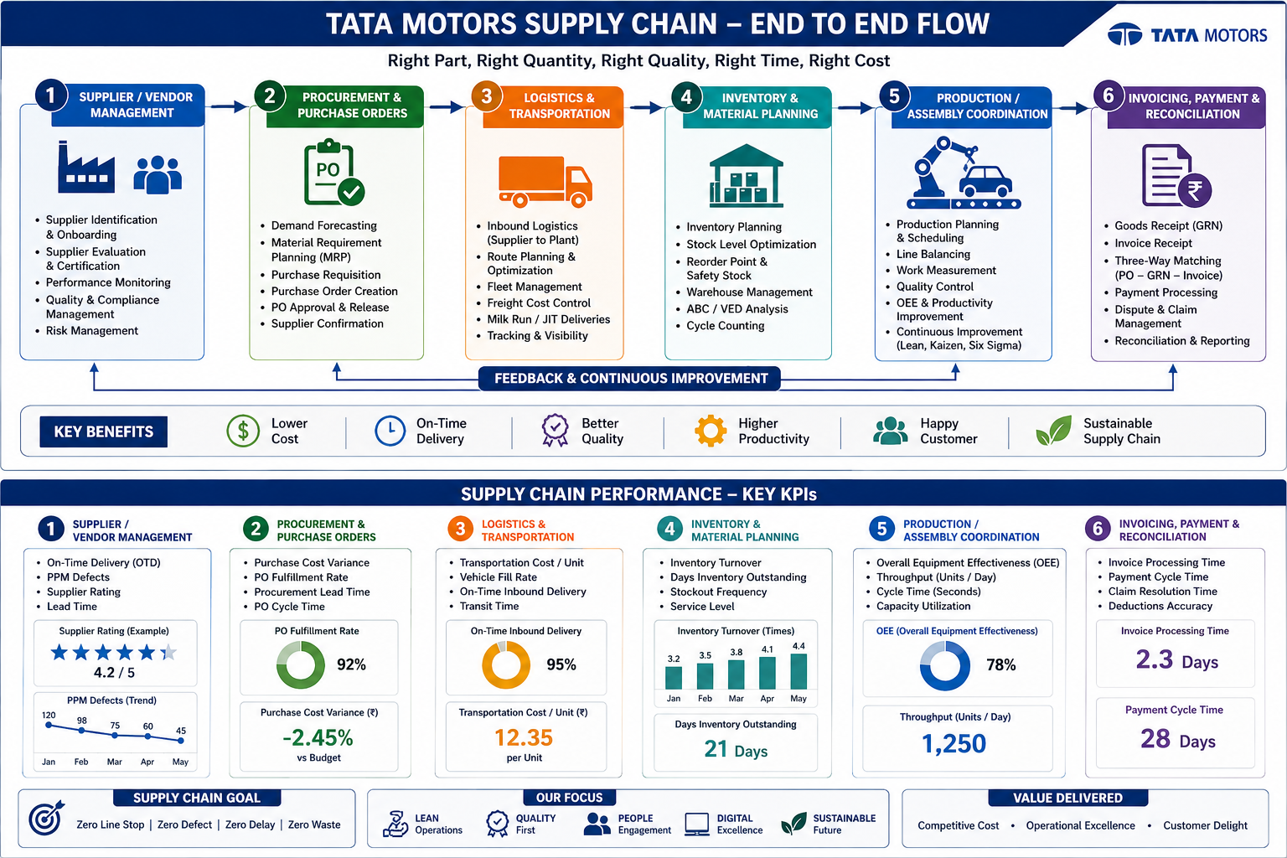

Key Supply Chain and Production Engineering Terminologies Used in Samprawah

1. SCM – Supply Chain Management

Definition
Management of the complete flow of materials, information, and finances from supplier to customer.
Example
Steel Supplier → Tata Motors → Dealer → Customer
Objective
- Right Material
- Right Quantity
- Right Time
- Right Cost

2) TML – Tata Motors Limited
- Refers to the manufacturing organization where Samprawah is implemented.
- Example:
Vendor supplies axle parts to TML Lucknow Plant.
3)ASN – Advance Shipping Notice

Definition
Electronic information sent by supplier before dispatching material.

Contains
- Part Number
- Quantity
- Vehicle Number
- Dispatch Date
- Expected Arrival

The implementation of effective unloading and material handling processes leads to better production planning, faster unloading of incoming materials, and reduced waiting time for vehicles. This improves material availability, enhances operational efficiency, and supports smooth plant operations.

Example
Supplier dispatches:
1000 bolts
ASN generated before truck reaches Tata Motors gate.

4.JIT – Just In Time

Definition
Material arrives exactly when needed.

Objective
Reduce inventory.

Example
Assembly line needs:
100 seats at 10:00 AM
Supplier delivers:
100 seats at 9:55 AM
No storage required.

5.JIS – Just In Sequence

Definition
Material reaches production line in exact assembly sequence.

Example
Vehicle order:
Red → Blue → White
Seats delivered:
Red seat → Blue seat → White seat
No sorting required.

6.Inventory

Definition
Stock of materials available in system.
Types
Raw Material
Steel Sheet

Ready vehicle

7.WIP – Work In Progress

Definition
Materials currently under production.

Formula
WIP=Throughput×Lead Time

Example
100 vehicles/day
Lead Time = 3 days
WIP = 300 vehicles

8.Lead Time

Definition
Time between order placement and order completion.

Example
Order placed Monday
Material received Thursday
Lead Time = 3 days

Objective
Reduce Lead Time.

9.Throughput

Definition
Output produced per unit time.

Example
500 chassis/day
Throughput = 500 chassis/day

10.FIFO – First In First Out

Definition
Material received first should be consumed first.

Importance
Avoids:
- Aging
- Obsolescence
- Damage

Example
Steel batch received on Monday used before Tuesday batch.

11.Warehouse Management System (WMS)

Definition
Software managing warehouse activities.

Functions

Benefits
- Faster operations
- Better inventory accuracy

12.Dynamic Slotting

Definition
Storage location changes automatically according to demand.

Example
Fast-moving bolts stored near dispatch area.
Slow-moving parts stored farther away.

13.Dock Assignment

Definition
Allocating unloading/loading bay to incoming truck.

Objective
Reduce truck waiting time.

14.Put-Away

Definition
Process of moving unloaded material into storage location.
Example:
Truck unloads engine parts.
Parts stored in rack A-12.

15.Retrieval

Definition
Taking material from warehouse for production.
Example:
Assembly line requests steering units.
Warehouse retrieves and supplies.

16.Kanban

Definition

Kanban in Samprawah is an electronic system that generates and tracks material replenishment requests based on actual consumption ,ensuring the right material reaches the right place at the right time while minimizing inventory.

Formula
N=D×L×(1+S)C

Example
Demand = 500/day
Lead Time = 2 days
Safety = 20%
Container = 50
Kanbans = 24

17.e-Kanban

Definition
Digital version of Kanban.

Advantages

19.BOM – Bill of Materials

Definition
List of all parts required to manufacture a product.

Example

Truck BOM
- Engine
- Chassis
- Transmission
- Wheels
- Seats

20.Kitting

Definition
Grouping all required components before assembly.
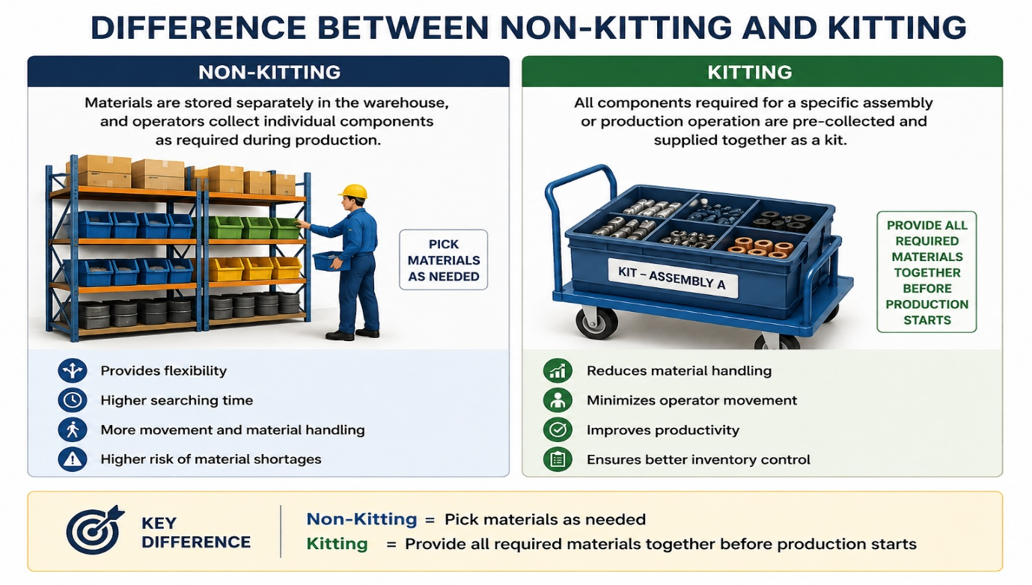

20.Aggregate Planning

Definition
Planning production quantity over medium-term horizon.

Purpose
Balance:
- Demand
- Capacity
- Workforce

21.Production Booking

Definition
Digital confirmation of production completion.

Example
Engine assembled.
System records production automatically.

22.Auto Replenishment

Definition
Automatic generation of material request.

Example
Inventory falls below minimum level.
System automatically creates replenishment order.

23.Track and Trace

Definition
Ability to track material movement throughout supply chain.

Example
Engine Serial No. E12345
Can be traced from supplier to customer.

24.Line Side Inventory

Definition
Inventory kept directly near assembly line.

Objective
Reduce operator movement.

25.Line Balancing

Definition
Equal distribution of work among stations.

Formula
Cycle Time = Available Production Time / Customer Demand

Example
480 minutes/day
Demand = 240 vehicles/day
Cycle Time = 2 minutes

26.Bottleneck

Definition
Slowest process limiting system output.

Example
Painting Capacity = 300 vehicles/day
Assembly Capacity = 500 vehicles/day
Painting becomes bottleneck.

27.OEE – Overall Equipment Effectiveness

Definition
Measures equipment productivity.
Formula:
OEE=Availability×Performance×Quality

28. Quality Interlock

Definition
System preventing defective part from moving to next station.

Example
Sensor detects missing bolt.
Conveyor stops automatically.

29.FPY – First Pass Yield

Definition
Percentage of products passing inspection first time.
Formula:
FPY = Good Units / Total Units × 100

30. Rework

Definition
Correction of defective product.

Example
Improper welding repaired.
Objective:
Minimize rework.

31.GPS Tracking

Definition
Real-time location tracking of vehicles.

Used For
- Dispatch visibility
- ETA prediction

32. ETA – Estimated Time of Arrival

Definition
Predicted arrival time of shipment.

Example
Truck expected to arrive at dealer at 5 PM.

33. OTD – On Time Delivery

Definition
Percentage of deliveries made before promised date.
Formula:
OTD = On-Time Deliveries / Total Deliveries × 100

World-Class Benchmark
95–98%

34. EOQ – Economic Order Quantity

Definition
Optimal quantity minimizing inventory cost.
EOQ= √[(2DS)/H]
Where:
- D = Demand
- S = Ordering Cost
- H = Holding Cost
35.)Safety Stock
Definition
Extra inventory maintained to handle uncertainty
Formula
Safety Stock = Maximum Demand − Average Demand

Purpose
Avoid stockouts.

36.Inventory Turnover

Definition
Number of times inventory is consumed annually.
Formula:
Inventory Turnover = Annual Consumption / Average Inventory
Higher is generally better.

37.Industry 4.0

Definition
Smart manufacturing using:
- IoT
- AI
- Sensors
- Real-time analytics
- Automation

38) e-kanban
Introduction
- E-Kanban (Electronic Kanban) is a digital material replenishment system used in the Samprawah Supply Chain Portal to ensure smooth and uninterrupted flow of materials between suppliers, warehouses, and production lines. It replaces traditional paper Kanban cards with real-time electronic signals and automated communication.
- In automotive manufacturing plants such as Tata Motors, E-Kanban helps implement Just-in-Time (JIT) and Lean Manufacturing by ensuring that materials are replenished only when required.
- Objectives of E-Kanban
- Ensure continuous material availability.
- Reduce excess inventory.
- Eliminate manual Kanban cards.
- Improve supply chain visibility.
- Support Just-in-Time manufacturing.
- Reduce stock-outs and production interruptions.

Samprawah Connection
The six digital strings are an Industry 4.0 implementation creating a digital thread from supplier to finished vehicle delivery.
Pick-to-Light (PTL) System
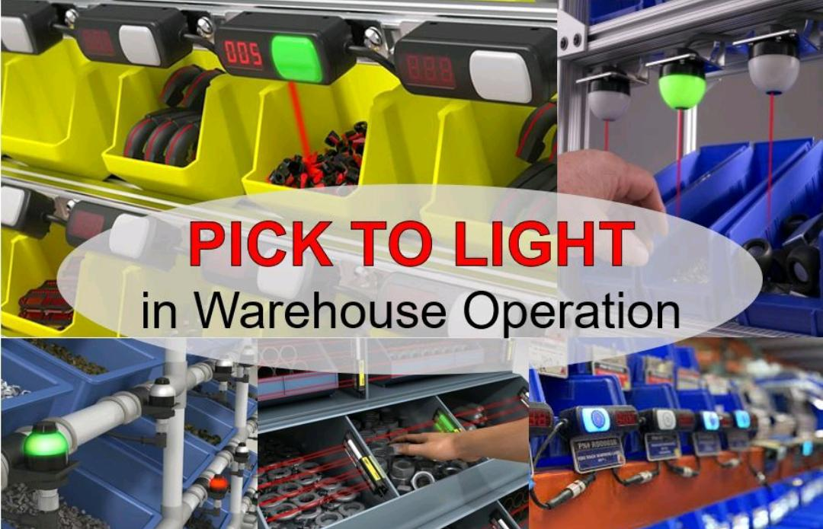
Introduction
Pick-to-Light (PTL) is an advanced warehouse automation technology used to improve the speed and accuracy of order picking operations. The system uses LED indicators and digital displays installed at storage locations to guide operators to the correct bin and indicate the quantity of items to be picked. It minimizes manual searching, reduces errors, and enhances overall warehouse productivity.
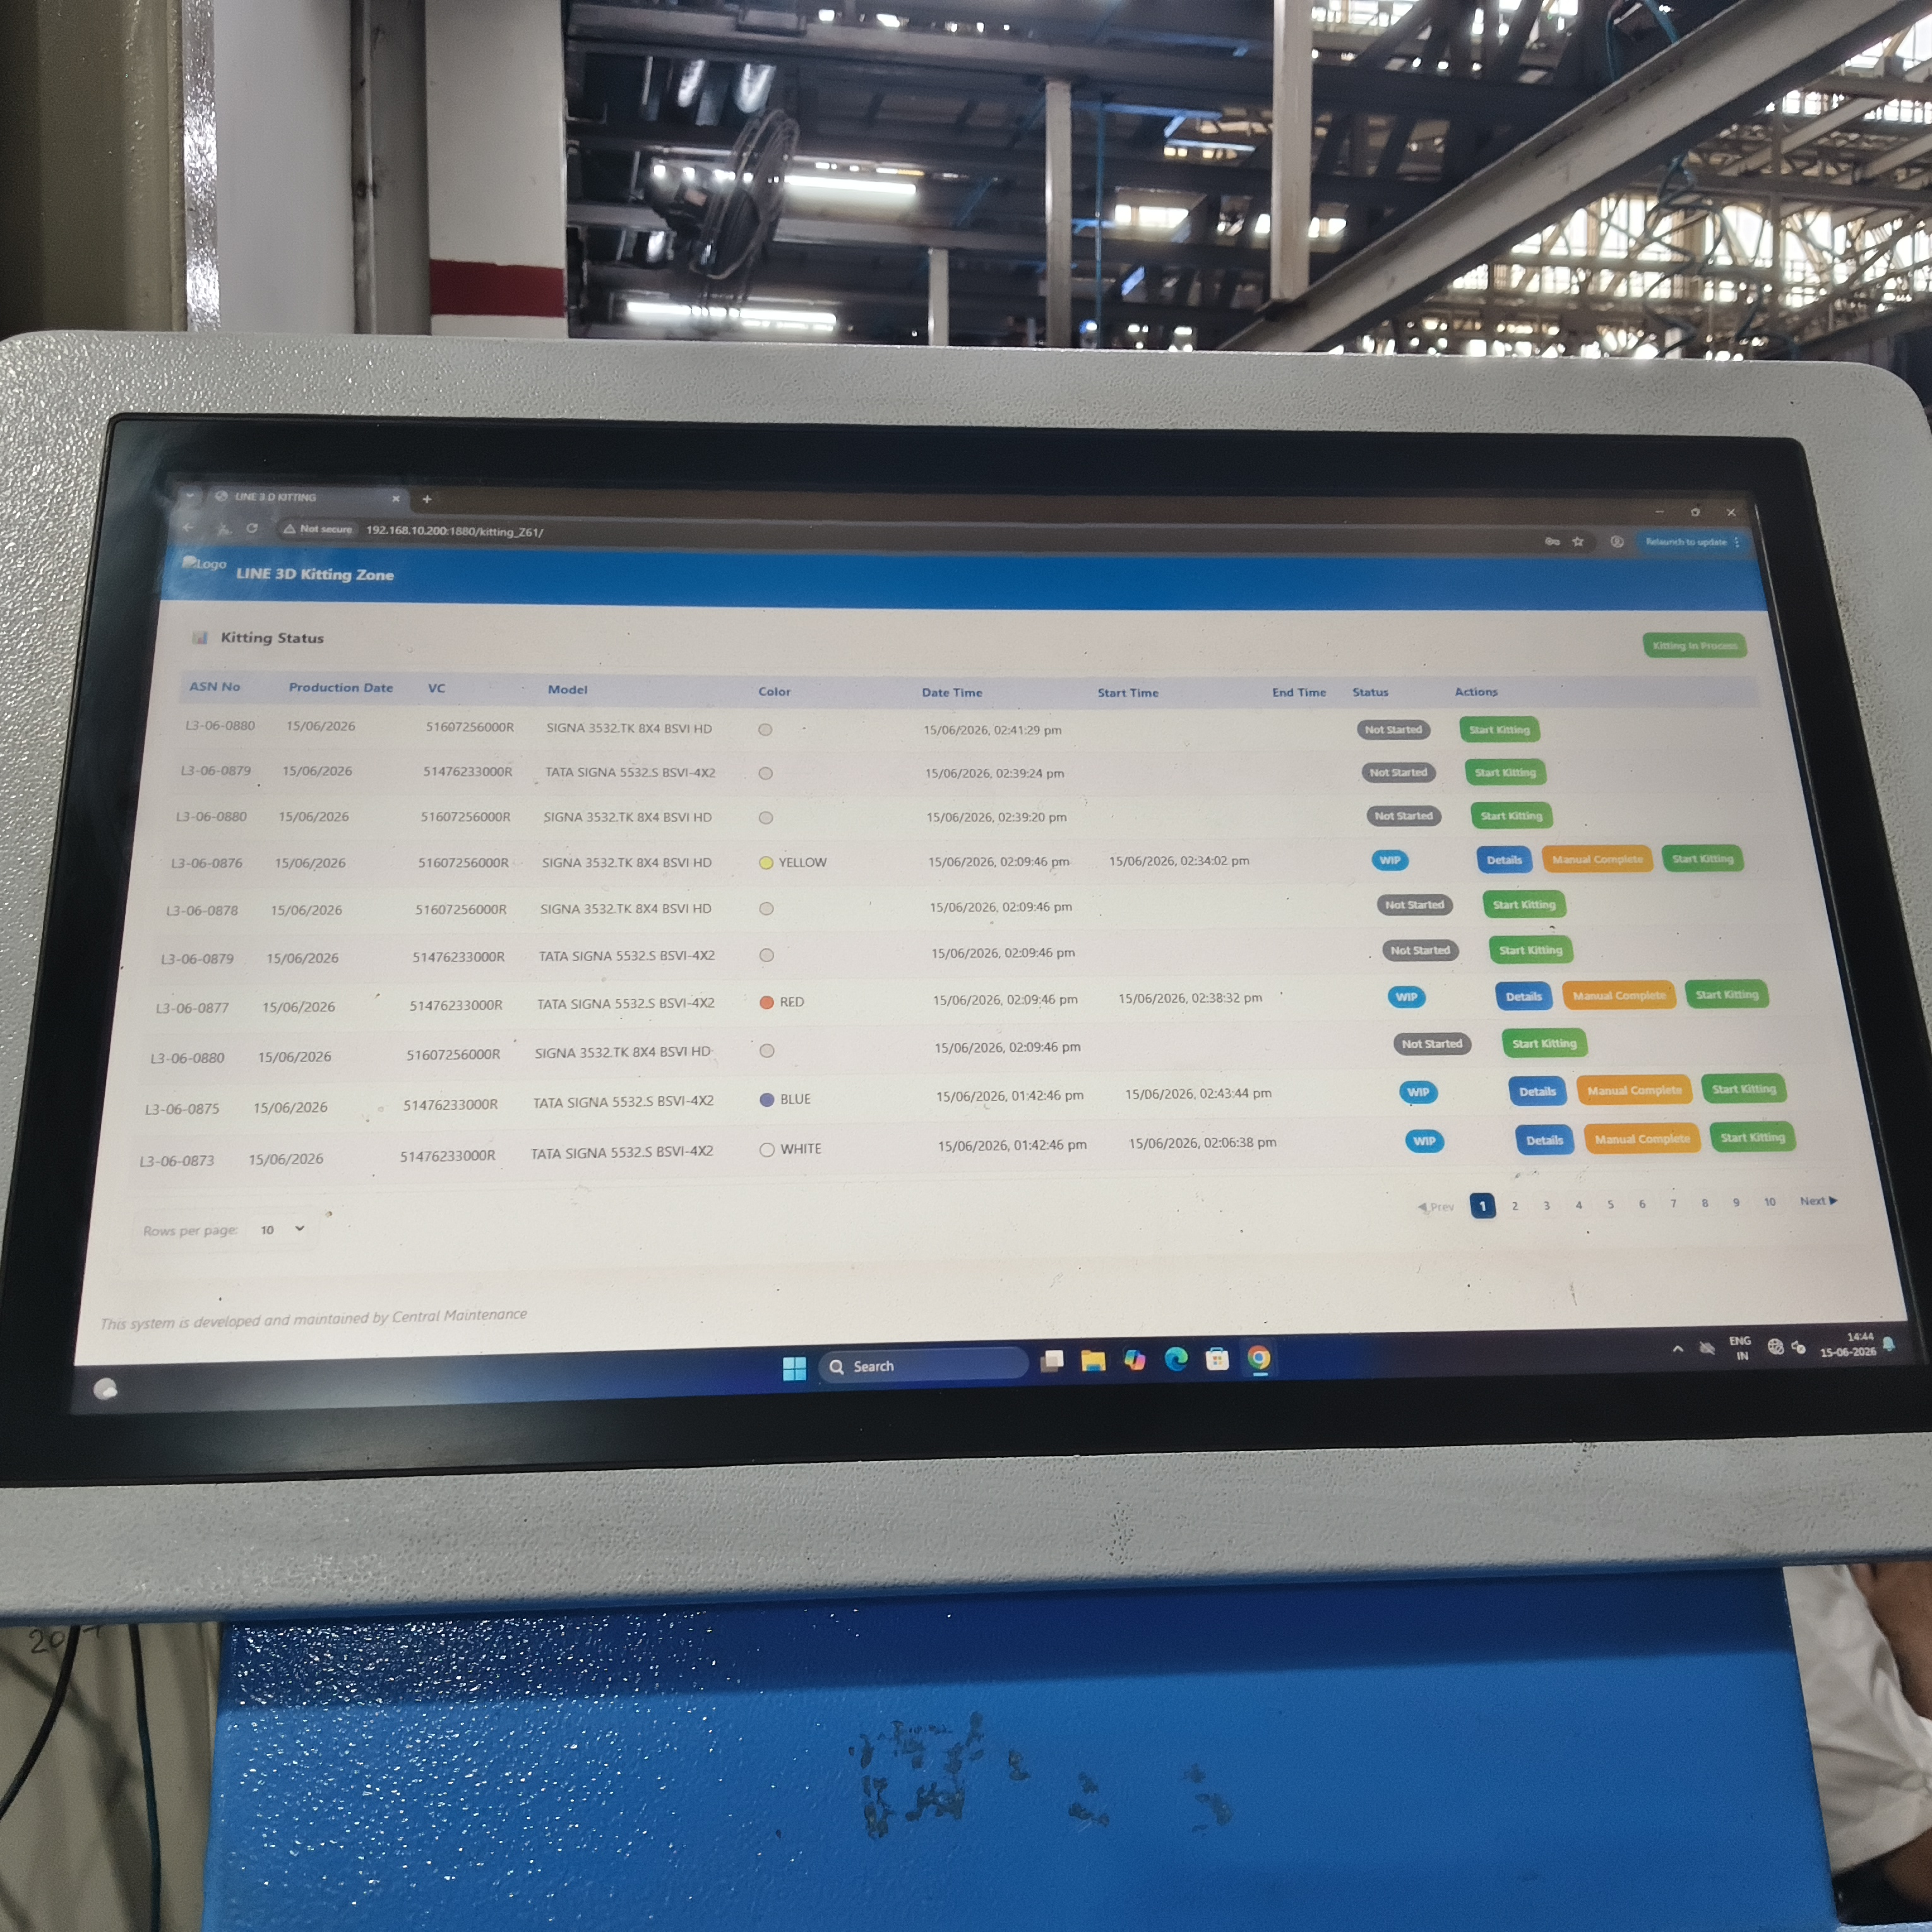
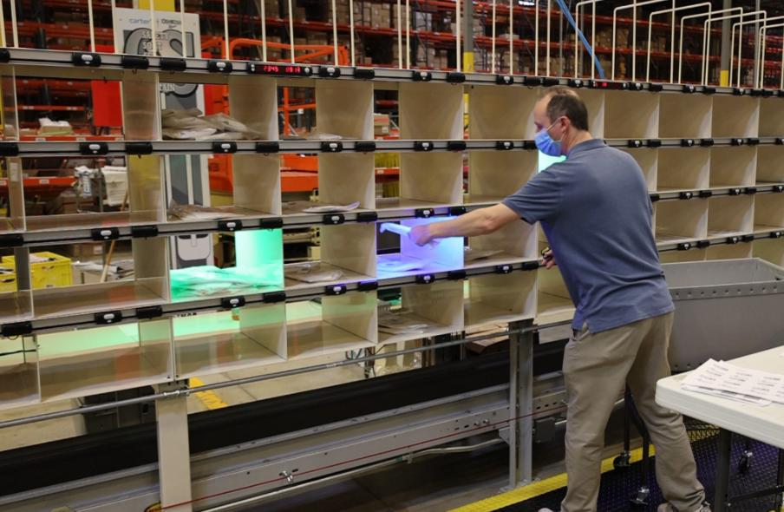
Working Principle
When an order is generated through the Warehouse Management System (WMS) or Enterprise Resource Planning (ERP) system, the corresponding storage locations are illuminated. The operator follows the light signals, picks the required quantity of material, and confirms the action by pressing a button. The inventory records are automatically updated in real time.


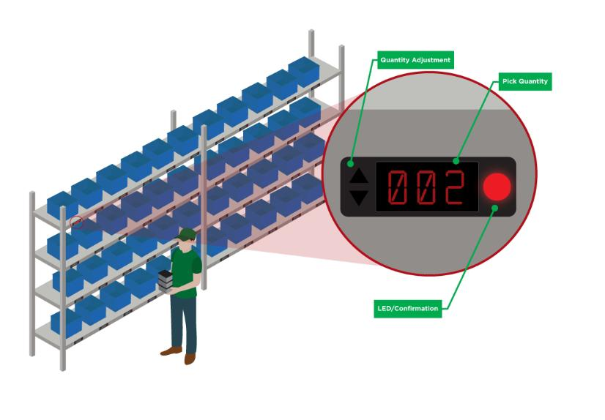
Key Components
- LED Light Indicators
- Digital Quantity Displays
- Confirmation Buttons
- Warehouse Management System (WMS)
- Communication Controller and Network

Benefits of Pick-to-Light

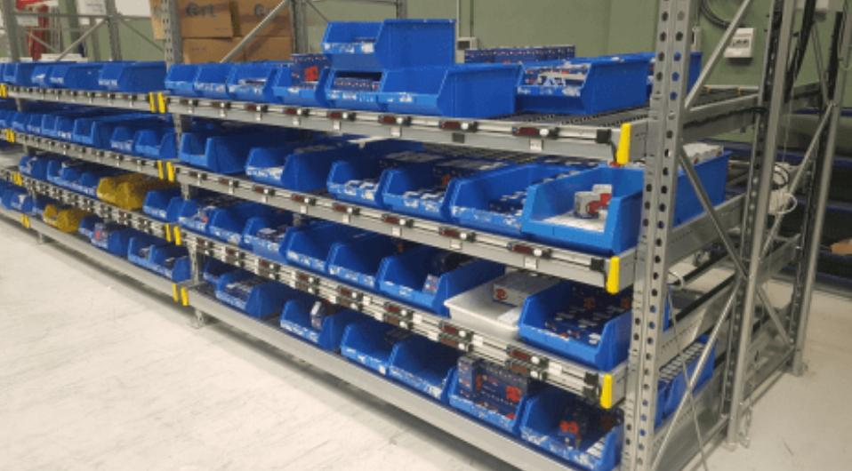
Applications in Supply Chain Management
Pick-to-Light systems are widely used in:

Importance in Commercial Vehicles Industry
In commercial vehicles manufacturing plants such as Tata Motors, thousands of components are stored and supplied to production lines. Pick-to-Light technology helps workers quickly identify the correct parts and quantities, ensuring uninterrupted material flow and reducing production delays. This contributes to efficient inventory management, higher production efficiency, and improved customer satisfaction.

Pros of Pick-to-Light (PTL)
- Increases picking accuracy by guiding operators to the correct location using visual indicators.
- Reduces order picking time, improving warehouse productivity and efficiency.
- Minimizes training requirements, making it easier for new workers to perform picking tasks.

Cons of Pick-to-Light (PTL)
- High initial investment cost for installation and system setup.
- Maintenance and technical issues can disrupt warehouse operations.
- Less suitable for warehouses with frequently changing layouts or product locations.
Conclusion
Pick-to-Light is an effective warehouse automation solution that enhances order-picking accuracy, reduces operational costs, and improves supply chain performance. Its implementation supports lean manufacturing practices and helps organizations achieve greater efficiency in inventory and material management.

Flow Diagram
Customer Order
↓
WMS/ERP System
↓
Storage Bin Light Activated
↓
Operator Picks Material
↓
Confirmation by Button Press
↓
Inventory Updated
↓
Material Supplied to Production/Dispatch

Hand-Held Terminals (HHT) in Supply Chain Management
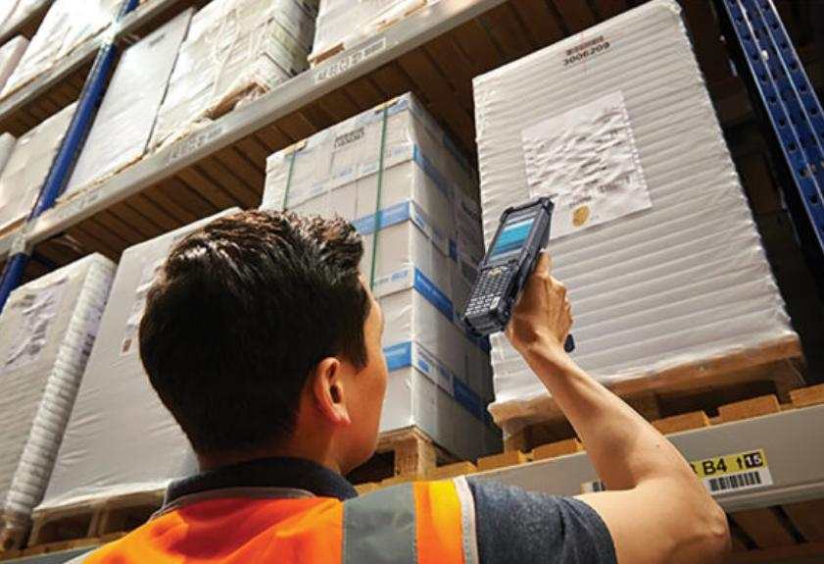
Introduction
Hand-Held Terminals (HHTs) are portable electronic devices used for real-time data collection, inventory management, material tracking, and warehouse operations. These devices are equipped with barcode scanners, RFID readers, wireless communication systems, and data-processing capabilities, enabling efficient management of inventory and logistics activities.

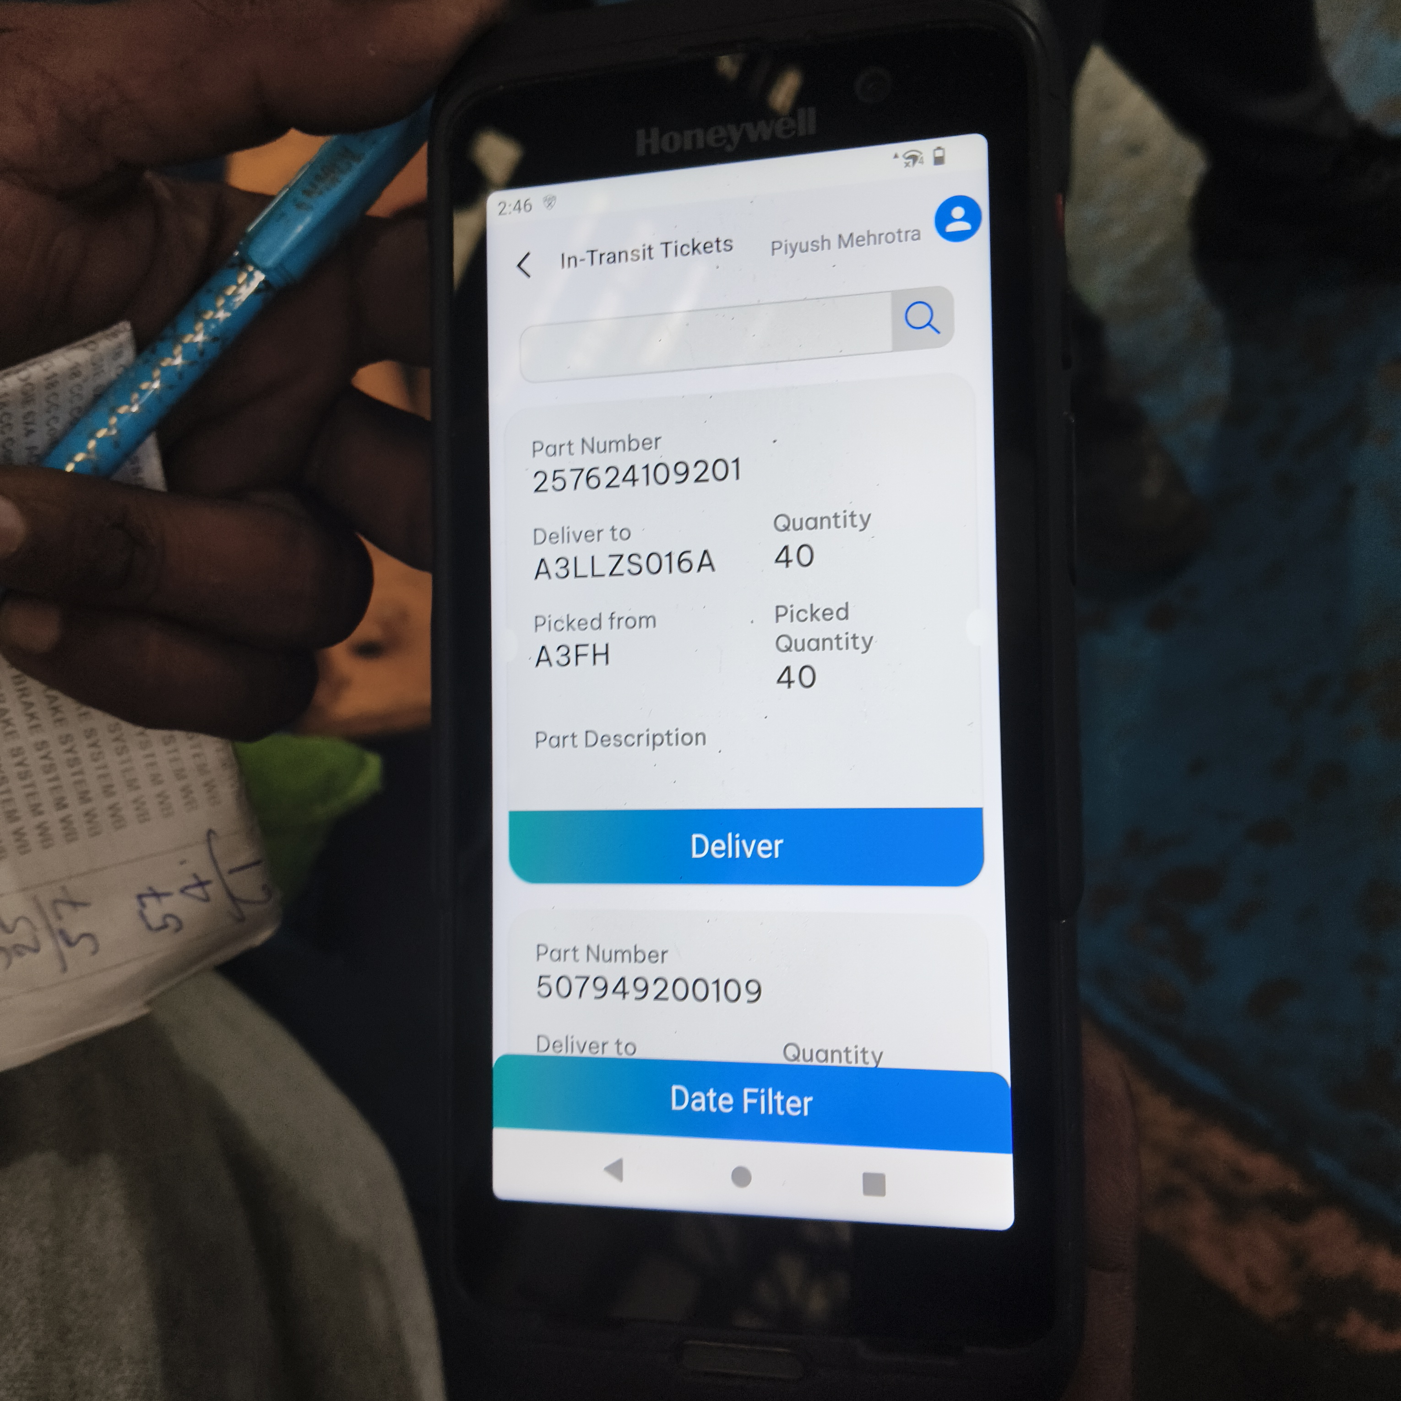
Working Principle
Hand-Held Terminals communicate with Warehouse Management Systems (WMS) or Enterprise Resource Planning (ERP) systems through wireless networks. Operators scan barcodes or RFID tags attached to materials, products, or storage locations. The captured data is instantly transmitted to the central database, ensuring accurate and real-time inventory updates.

Key Features
- Barcode and QR Code Scanning
- RFID Reading Capability
- Wireless Connectivity (Wi-Fi/Bluetooth)
- Real-Time Data Transmission
- Inventory Tracking and Monitoring
- Rugged Design for Industrial Environments
Applications in Supply Chain Management

Benefits

Importance in Automotive Industry
In automotive manufacturing plants such as Tata Motors, Hand-Held Terminals are extensively used for tracking components, managing inventory, verifying material movement, and ensuring timely supply of parts to production lines. HHTs help maintain inventory accuracy, reduce material shortages, and improve overall supply chain efficiency.
Advantages/Pros
- Faster data collection and processing.
- Improved traceability of materials.
- Reduced operational costs.
- Better inventory control.
- Increased workforce efficiency.

Disadvantages/Cons
- High procurement and maintenance costs compared to manual systems.
- Battery dependency can cause operational delays if devices are not adequately charged.
Conclusion
Hand-Held Terminals are essential tools in modern supply chain and warehouse management systems. By enabling real-time data capture and inventory tracking, they improve operational efficiency, inventory accuracy, and overall supply chain performance.

Material Tracking Process Using HHT
Material Receipt
↓
Barcode/RFID Scanning
↓
Data Captured by HHT
↓
Information Sent to WMS/ERP
↓
Inventory Updated
↓
Storage / Production Supply / Dispatch

1. Kitting
Definition
Kitting is the process of collecting and grouping all the components, parts, and materials required for a specific assembly operation into a single kit before they are supplied to the production line.

Example
For assembling a truck dashboard, all required components such as switches, wiring harnesses, fasteners, and panels are packed together and sent as one kit to the assembly station.

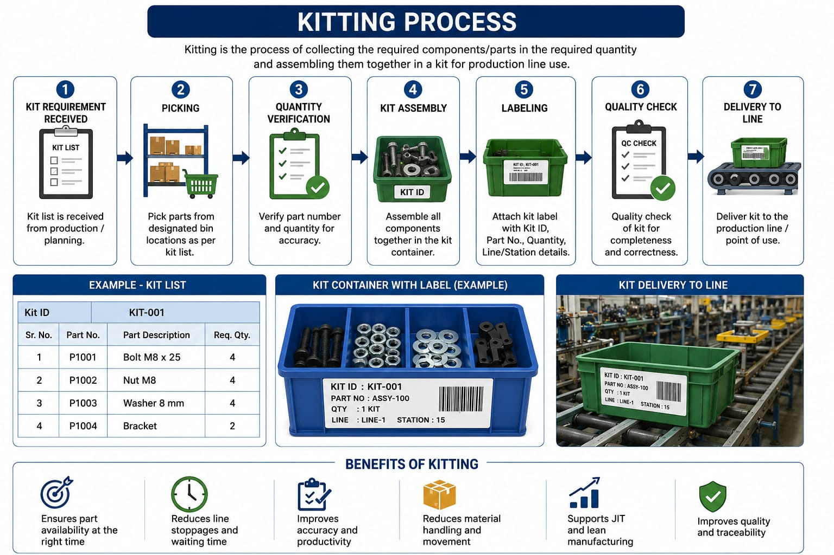
Benefits

Importance at Tata Motors
Kitting ensures that assembly-line operators receive the exact parts required for vehicle assembly, reducing downtime and improving productivity.
2. Picking
Definition
Picking is the process of selecting and retrieving materials or components from warehouse storage locations based on production or customer requirements.

Types of Picking

Benefits
- Accurate material issue.
- Faster order fulfillment.
- Improved inventory control.
- Reduced material shortages.
Example
A warehouse operator picks brake assemblies, bolts, and wiring harnesses from designated storage bins for vehicle production.
3. Dropping
Definition
Dropping refers to the delivery or placement of picked materials at the designated production line, workstation, assembly area, or storage location for immediate use.
Process
Warehouse Picking Transportation Dropping at Production Line
Benefits

Example
After picking the required parts, logistics personnel deliver (drop) the materials directly to the truck assembly station.
4. Goliath Linkage
Definition
Goliath Linkage is a material tracking and supply chain integration system used in automotive manufacturing to establish a digital connection between inventory management, warehouse operations, production planning, and assembly-line requirements.
It ensures that materials are traced and linked from supplier receipt to final vehicle assembly, enabling real-time visibility and control.

Importance in Tata Motors Supply Chain
Goliath Linkage helps integrate warehouse operations, material movement, and production requirements. It ensures that the right material reaches the right assembly station at the right time, supporting Lean Manufacturing and Just-in-Time (JIT) systems.
Relationship Between Kitting, Picking, Dropping and Goliath Linkage
Production Schedule
↓
Goliath Linkage System
↓
Material Requirement Generated
↓
Picking from Warehouse
↓
Kitting of Components
↓
Material Dropping at Line Side
↓
Vehicle Assembly
↓
Inventory Updated in System

Binning Process in Supply Chain Management
Definition
Binning is the process of assigning and storing materials, components, or products in specific storage locations called bins within a warehouse or store. Each bin is given a unique identification code to facilitate easy storage, retrieval, tracking, and inventory management.
In automotive industries such as Tata Motors, binning is essential for organizing thousands of components and ensuring that materials can be quickly located and supplied to production lines
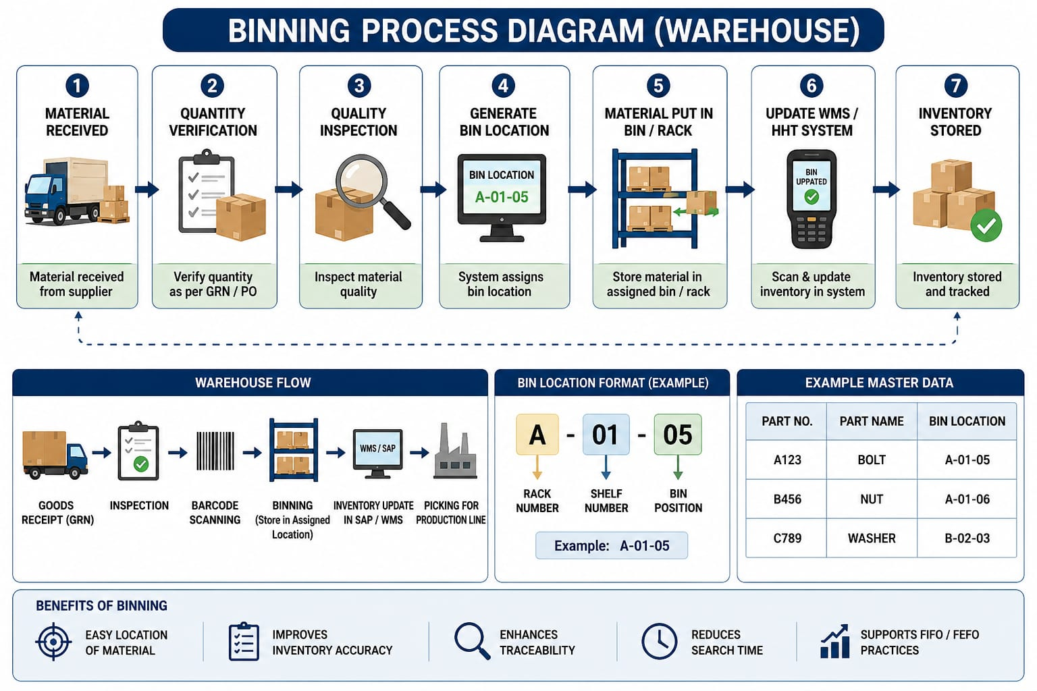
Binning Process
1. Material Receipt
Materials are received from suppliers and inspected for quality and quantity.
2. Material Identification
Each item is assigned a barcode, RFID tag, or part number for identification.
3. Bin Allocation
A suitable storage location (bin) is assigned based on:
- Material type
- Size and weight
- Frequency of usage
- Safety requirements
4. Material Storage
The material is placed in the designated bin location.
5. System Update
The Warehouse Management System (WMS) or ERP system records the bin location and stock quantity.
6. Retrieval for Production
When required, materials are picked from their assigned bins and supplied to the production line.

Types of Bins
- Fixed Bins – Permanent storage location for a specific item.
- Dynamic Bins – Storage location can change based on availability.
- Rack Bins – Located on warehouse racks.
- Floor Bins – Materials stored directly on the warehouse floor.
- Line-Side Bins – Located near production workstations for fast access.

Importance in Commercial Vehicle Industry
In a commercial vehicle manufacturing plant, thousands of components such as bolts, nuts, wiring harnesses, brake parts, and engine components are stored in different bins. Proper binning ensures:
1.Quick material availability
2.Improved supply chain performance
3.Accurate inventory records
4.Reduced production delays
5.Efficient warehouse operations

Example
Suppose a brake assembly component is assigned to:
Bin Location: A-03-B-12
Where:
- A = Warehouse Zone
- 03 = Rack Number
- B = Shelf Number
- 12 = Bin Number
When production requires this component, the warehouse operator can immediately locate and pick it from the specified bin.
Binning is a fundamental warehouse management practice that ensures systematic storage and tracking of materials. It improves inventory accuracy, reduces retrieval time, and supports efficient material flow, making it a critical component of modern supply chain management and automotive manufacturing operations.

Binning Process Flow
Material Receipt
↓
Quality Inspection
↓
Barcode/RFID Tagging
↓
Bin Allocation
↓
Storage in Bin Location
↓
System Update (ERP/WMS)
↓
Picking for Production
↓
Assembly Line Supply

Conclusion
Kitting, Picking,Binning and Dropping are critical warehouse and material-handling activities in automotive manufacturing. Goliath Linkage acts as the digital backbone connecting these operations with inventory and production systems. Together, they ensure smooth material flow, reduced inventory costs, improved productivity, and efficient supply chain management in organizations such as Tata Motors.

- Requires periodic review as operational requirements and priorities change.

Cycle Counting in Supply Chain Management

Definition
Cycle Counting is an inventory auditing technique in which a small subset of inventory is counted regularly throughout the year instead of performing a full physical inventory count at once.
It helps maintain accurate inventory records without disrupting production and warehouse operations.

Simple Meaning
Instead of counting all 50,000 inventory items once a year:
- Count 100 items every day
- Count 500 items every week
Eventually, the entire inventory gets verified over a cycle.

Why is Cycle Counting Important?
In automotive industries like Tata Motors:
- Thousands of parts are stored.
- Daily production depends on inventory accuracy.
- Incorrect inventory data can cause production stoppages.
Cycle counting helps:

KPI Improvement Through Reverse & Recognition Method
(For Supply Chain Management and Tata Motors Samprawah Project)

KPI = Key Performance Indicator
KPIs measure how effectively a process achieves its objectives.
Examples:
- OTD (On-Time Delivery)
- Inventory Accuracy
- OEE
- Supplier Performance
- Warehouse Productivity
- Cycle Time

1. Reverse KPI Analysis

Definition
Reverse KPI Analysis means starting from a poor KPI result and tracing backward to identify the root causes.

Process
Poor KPI
↓
Identify Contributing Factors
↓
Find Root Cause
↓
Implement Corrective Action
↓
Monitor KPI Improvement

Example: OTD Reduced from 98% to 85%

Reverse Analysis:
Poor OTD
↓
Late Vehicle Dispatch
↓
Material Shortage
↓
Supplier Delay
↓
No ASN Visibility
Corrective Action:
- Real-time ASN tracking
- Vendor performance monitoring
- Safety stock management
Result:
OTD improved to 97%

Benefits

2. Recognition-Based KPI Improvement

Definition
Recognition means rewarding teams or individuals who achieve KPI targets.
Examples
Warehouse Team
Target Inventory Accuracy
98%
Achieved
99.5%
Recognition:
- Employee of the Month
- Appreciation Certificate
- Incentives

Benefits

Pros of Cycle Counting
- Improves inventory accuracy by regularly verifying stock levels.
- Reduces the need for full physical inventory counts, minimizing operational disruptions.
- Helps identify inventory discrepancies and process issues at an early stage.

Cons of Cycle Counting
- Requires continuous time and labor commitment throughout the year.
- May not detect all inventory errors if some items are counted infrequently.
- Results depend on disciplined execution and accurate record-keeping.

Other Effective Ways of Improving KPIs
3. Kaizen (Continuous Improvement)

Definition
Small continuous improvements made daily.

Example
Before:
Operator walks 20 m for components.
After:
Line-side storage introduced.
Walking reduced to 5 m.
Result:
Higher productivity.

4. Root Cause Analysis (RCA)

Tools
- 5 Why Analysis
- Fishbone Diagram
- Pareto Analysis

Example
Problem:
Inventory mismatch.
Why?
Wrong material issue.
Why?
Barcode not scanned.
Root cause identified and corrected.
5. Benchmarking

Definition
Comparing performance with industry leaders.

Example

KPI | Current | Best Practice
OTD | 92% | 98%
Inventory Accuracy | 95% | 99%

6. Automation

Examples
- Barcode scanners
- RFID
- AGV (Automated Guided Vehicles)
- Automated Storage Systems

Benefits

7. Digitalization

Samprawah Example
- Real-time material tracking
- Digital ASN
- e-Kanban
- Vehicle tracking

Impact
Improves:

8. Employee Training

Example
Warehouse staff trained in:
- FIFO
- Barcode scanning
- Inventory management

Result
Fewer errors and higher KPI performance.

9. Lean Manufacturing
Focus on eliminating wastes:

TIMWOOD
- Transportation
- Inventory
- Motion
- Waiting
- Overproduction
- Overprocessing
- Defects
Reducing waste directly improves KPIs.
10. Visual Management

Examples
- KPI Dashboard
- Andon Boards
- Traffic Light Indicators

Pros of Lean Manufacturing

11. Preventive Maintenance

Objective
Prevent machine breakdowns.

Impact
Improves:
- OEE
- Throughput
- Production Efficiency
12. Supplier Development Programs

Activities
- Vendor audits
- Vendor scorecards
- Joint improvement projects

Impact
Improves:

13. Data Analytics

Uses
Analyze:
- Demand trends
- Delivery delays
- Inventory patterns

Benefits
Predictive decision making.

14. PDCA Cycle

Plan

Identify problem
↓

Do

Implement solution
↓

Check

Measure KPI
↓

Act

Standardize improvement
This is one of the most widely used KPI improvement frameworks in manufacturing.

KPI Improvement Framework for Tata Motors Samprawah
Method | KPI Improved
Reverse KPI Analysis | OTD, Inventory Accuracy
Recognition Programs | Productivity, Quality
Kaizen | Cycle Time, Productivity
RCA | Quality, Inventory Accuracy
Benchmarking | All KPIs
Automation | OEE, Throughput
Digitalization | OTD, Supplier Performance
Training | Quality, Productivity
Lean Manufacturing | Cost, Lead Time
Preventive Maintenance | OEE
Supplier Development | Supplier OTD
PDCA | Continuous Improvement

Kaizen in Supply Chain Management
(Production & Industrial Engineering Perspective)

Definition
Kaizen is a Japanese term:
- Kai = Change
- Zen = Better
Meaning:

“Continuous Improvement”
Kaizen focuses on making small, continuous improvements involving everyone in the organization, from operators to top management.

Kaizen Cycle

Identify Problem
↓

Analyze Current Process
↓

Suggest Improvement
↓

Implement Improvement
↓

Measure Results
↓
Standardize New Method

(Repeat continuously)

Kaizen in Supply Chain Management

Objectives

Types of Waste Eliminated by Kaizen

TIMWOOD
Waste | Meaning
T | Transportation
I | Inventory
M | Motion
W | Waiting
O | Overproduction
O | Overprocessing
D | Defects
Example 1: Warehouse Kaizen

Before
Operator walks:
100 meters
to pick components.

Improvement
Fast-moving items relocated near dispatch area.

After
Walking distance:
30 meters

Benefit

Example 2: Samprawah – Flow House to Line Side

Problem
Material replenishment delayed.

Kaizen
Implemented e-Kanban system.

Result
- Real-time replenishment
- Reduced stockouts
- Improved line availability

Example 3: Vendor to TML Gate

Problem
Truck waiting time = 3 hours

Kaizen
Implemented ASN (Advance Shipping Notice).

Result
Truck waiting time reduced to 45 minutes.

Kaizen Tools
1. 5S
S | Meaning
Seiri -> | Sort
Seiton-> | Set in Order
Seiso -> | Shine
Seiketsu | ->Standardize
Shitsuke | ->Sustain
Example
Organized warehouse locations.
Result:
Faster material retrieval.
2. 5 Why Analysis

Problem
Production stopped.
Why?
Material unavailable.
Why?
Inventory inaccurate.
Why?
Wrong issue entry.
Why?
Operator skipped scanning.
Root cause identified.
3. PDCA Cycle

Plan

↓ (Identify problem)

Do

↓( Implement solution)

Check

↓( Measure result)
Act
Standardize improvement

Lean Manufacturing
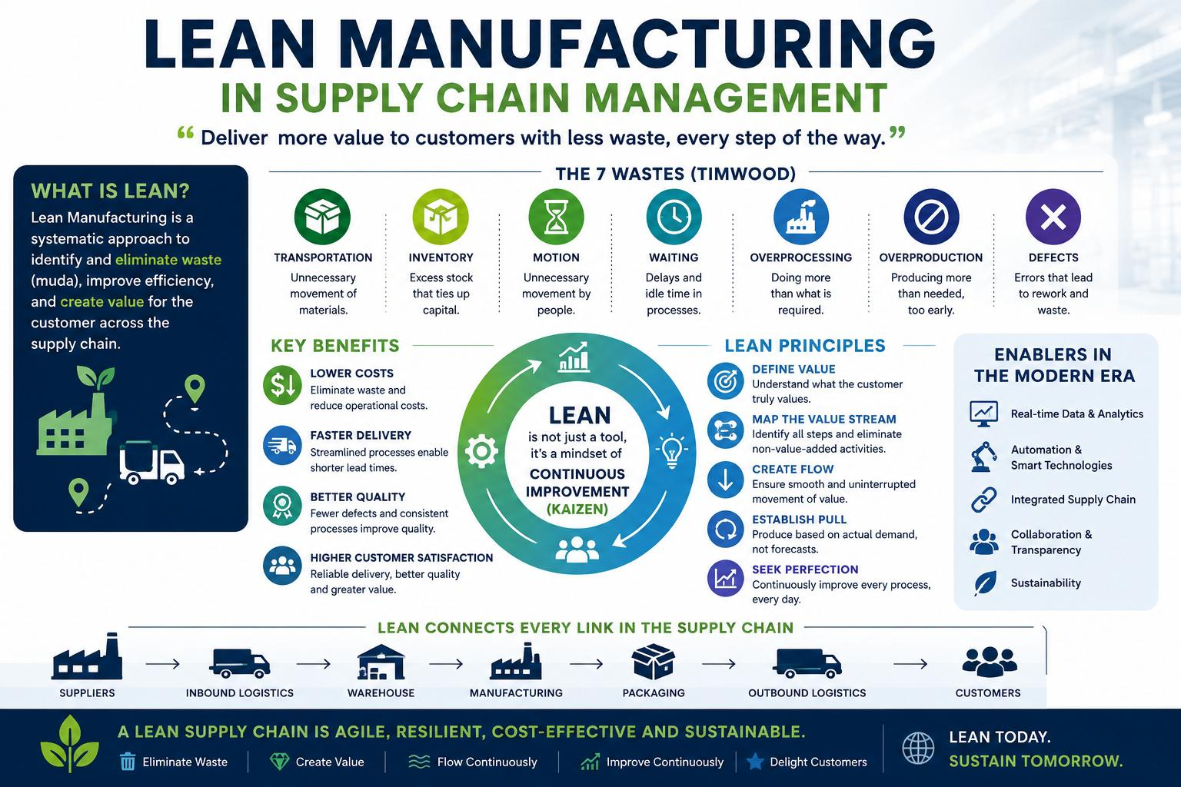

Definition
Lean Manufacturing is a production philosophy that focuses on maximizing customer value while minimizing waste (Muda) through continuous improvement and efficient resource utilization.
Objective
"Do more with less"
“Do more with less”
Less waste, less inventory, less time, less cost, and higher quality.

Core Principles of Lean Manufacturing
- Identify Value – Understand customer requirements.
- Map Value Stream – Identify all activities in the process.
- Create Flow – Ensure smooth material and information flow.
- Establish Pull System – Produce only when needed.
- Pursue Perfection – Continuous improvement (Kaizen).

7 Wastes (TIMWOOD)
Waste | Meaning
Transportation | Unnecessary movement of materials
Inventory | Excess stock
Motion | Unnecessary movement of people
Waiting | Idle time
Overproduction | Producing more than required
Overprocessing | Extra processing steps
Defects | Rework and scrap

Important Lean Tools
- 5S
- Kaizen
- Kanban
- JIT (Just-In-Time)
- JIS (Just-In-Sequence)
- Value Stream Mapping (VSM)
- Poka-Yoke (Mistake Proofing)
- Andon System
- TPM (Total Productive Maintenance)
Lean Manufacturing in Samprawah
Digital String | Lean Application
Vendor → TML Gate | JIT Material Supply
TML Gate → Flow House | Reduced Warehouse Waste
Flow House → Line Side | Kanban Replenishment
Aggregate Shop → Chassis Line | Reduced WIP
Chassis Line → SFLT | Defect Reduction
TML Gate → FBV | Efficient Dispatch Planning

Inventory Turnover
Definition
Inventory Turnover is a KPI that measures how many times inventory is consumed, sold, or replaced during a specific period (usually one year).
It indicates how efficiently a company manages its inventory.
Formula
Inventory Turnover=
Annual Consumption or Cost of Goods Sold/Average Inventory
Numerical Example
Annual Consumption = ₹50,00,000
Average Inventory = ₹10,00,000
Inventory Turnover
= 50,00,000 ÷ 10,00,000
= 5
Interpretation
The inventory is replenished 5 times per year.
Interpretation
Inventory Turnover | Meaning
High : | Fast-moving inventory, efficient inventory management
Moderate : | Balanced inventory levels
Low : | Excess inventory, slow-moving stock, higher carrying cost
Example in Tata Motors
If engine components worth ₹20 crore are consumed annually and the average inventory maintained is ₹4 crore:
Inventory Turnover = 20 ÷ 4 = 5.
This means the stock of engine components is completely utilized and replenished 5 times in a year.

Relation with Samprawah
Samprawah improves Inventory Turnover by:

Value Chain Management (VCM)
Definition
Value Chain Management (VCM) is the process of managing and optimizing all activities involved in creating value for customers, from raw material procurement to final product delivery and after-sales service.
The concept was introduced by Michael Porter.
Objective
To maximize customer value while minimizing cost across the entire supply chain.
Value Chain Activities
Primary Activities
1. Inbound Logistics
Activities related to receiving and storing materials.
Examples:
- Supplier management
- Transportation
- Warehousing
2. Operations
Conversion of raw materials into finished products.
Examples:
- Fabrication
- Assembly
- Painting
3. Outbound Logistics
Distribution of finished products.
Examples:
- Vehicle dispatch
- Dealer delivery
4. Marketing & Sales
Activities that create customer demand.
Examples:
- Product promotion
- Dealer network
5. Service
After-sales support.
Examples:
- Warranty
- Vehicle servicing
Support Activities
1.)Procurement
Purchasing materials and services.
2.)Technology Development
Automation, ERP, Industry 4.0 systems.
3.)Human Resource Management
Recruitment and training.
4.)Firm Infrastructure
Management, finance, quality systems.
Example
Without Value Chain Management
- Excess inventory
- Long lead time
- Delayed deliveries
With Value Chain Management
- JIT supply
- Faster production
- Lower costs
- Higher customer satisfaction

Value Chain in Tata Motors
Supplier
↓
TML Gate
↓
Warehouse / Flow House
↓
Production Shops
↓
Assembly Line
↓
Quality Inspection
↓
Vehicle Dispatch
↓
Dealer
↓
Customer
Each stage adds value to the final vehicle.

Pros and Cons of Value Chain Management

Integrated Logistics Management (ILM)

Definition
Integrated Logistics Management (ILM) is the coordinated management of all logistics activities—from procurement of raw materials to delivery of finished products—to ensure the right product reaches the right place, at the right time, in the right quantity, and at the lowest possible cost.
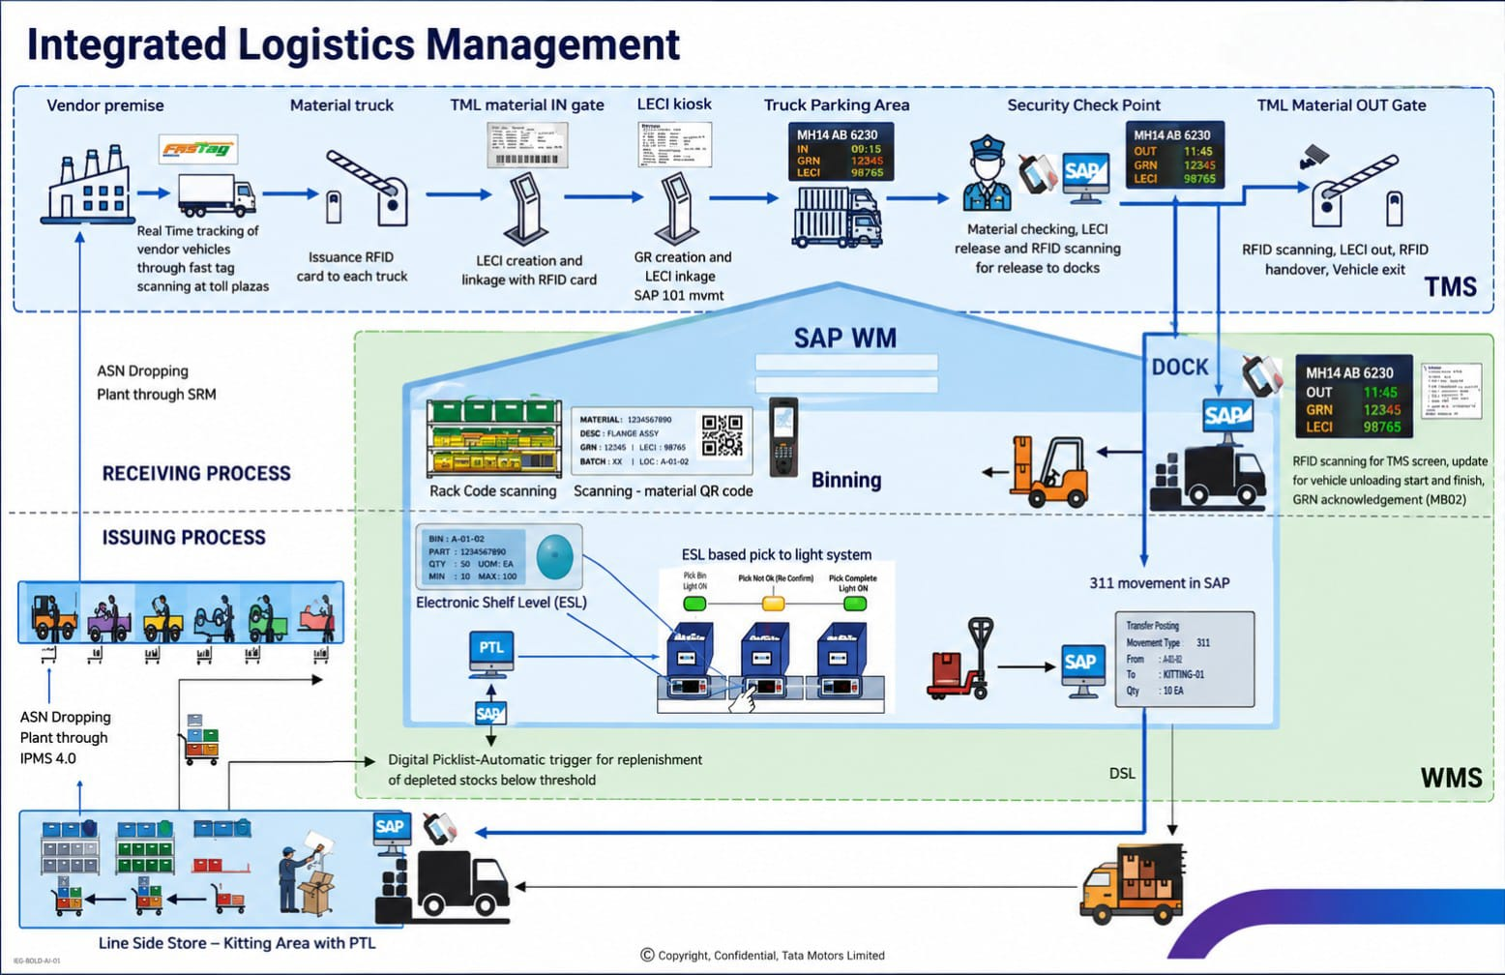

Objective
To achieve seamless flow of materials, information, and products across the entire supply chain.
Components of Integrated Logistics Management
1. Procurement Logistics
Management of material sourcing and supplier coordination.

Activities:
- Purchasing
- Supplier management
- Material planning
2. Inbound Logistics
Movement of materials from suppliers to the manufacturing plant.
Activities:
- Transportation
- Receiving
- Unloading
3. Warehouse Management
Storage and control of inventory.
Activities:
- Put-away
- Picking
- Cycle counting
- Inventory control
4. Material Handling
Movement of materials within the plant.
Examples:
- Forklifts
- Conveyors
- AGVs
5. Production Logistics
Ensuring timely material availability for production.
Activities:
- Line feeding
- e-Kanban
- JIT supply
6. Outbound Logistics
Movement of finished products to customers or dealers.
Activities:
- Vehicle dispatch
- Route planning
- Fleet management

7. Information Flow
Real-time sharing of logistics information.
Examples:
- ERP
- SAP
- Samprawah
- GPS Tracking

Integrated Logistics Flow
Supplier
↓
Procurement
↓
Inbound Transportation
↓
Warehouse
↓
Production
↓
Finished Goods Storage
↓
Outbound Transportation
↓
Dealer/Customer

Importance in Supply Chain Management

Relevance to Samprawah
Digital String | Logistics Function
Vendor → TML Gate | Inbound Logistics
TML Gate → Flow House | Receiving & Warehousing
Flow House → Line Side | Internal Logistics
Aggregate Shop → Chassis Line | Production Logistics
Chassis Line → SFLT | Finished Vehicle Management
TML Gate → FBV | Outbound Logistics
Thus, Samprawah is a practical example of Integrated Logistics Management in Tata Motors.

Important KPIs in Integrated Logistics Management
Inventory Turnover
Inventory Turnover=Annual ConsumptionAverage Inventory

On-Time Delivery (OTD)
OTD (%) =
(On-Time Deliveries ÷ Total Deliveries) × 100

Inventory Accuracy
Inventory Accuracy (%) =
(Correct Records ÷ Total Records) × 100

Logistics Cost Percentage
Logistics Cost (%) =
(Logistics Cost ÷ Sales Revenue) × 100

Pros/Benefits

Role of a Production & Industrial Engineer
A Production & Industrial Engineer contributes to ILM by:

Industry 4.0 and Supply Chain Management in the Commercial Vehicles Industry: A Case of Tata Motors Commercial Vehicles
Introduction
Industry 4.0 represents the fourth industrial revolution, characterized by the integration of digital technologies such as the Internet of Things (IoT), Artificial Intelligence (AI), Big Data Analytics, Cloud Computing, Robotics, and Automation into manufacturing and supply chain operations. In the commercial vehicles sector, Industry 4.0 enables real-time visibility, enhanced productivity, improved quality, and efficient supply chain management.
For commercial vehicle manufacturers like Tata Motors, Industry 4.0 plays a crucial role in managing complex supply chains involving thousands of suppliers, components, warehouses, production facilities, and distribution networks.
Industry 4.0 Technologies Used in Commercial Vehicles Supply Chains
1. Internet of Things (IoT)
IoT devices and sensors collect real-time data from machines, warehouses, vehicles, and production lines.
Applications:

Benefits
- Reduced downtime
- Better inventory control
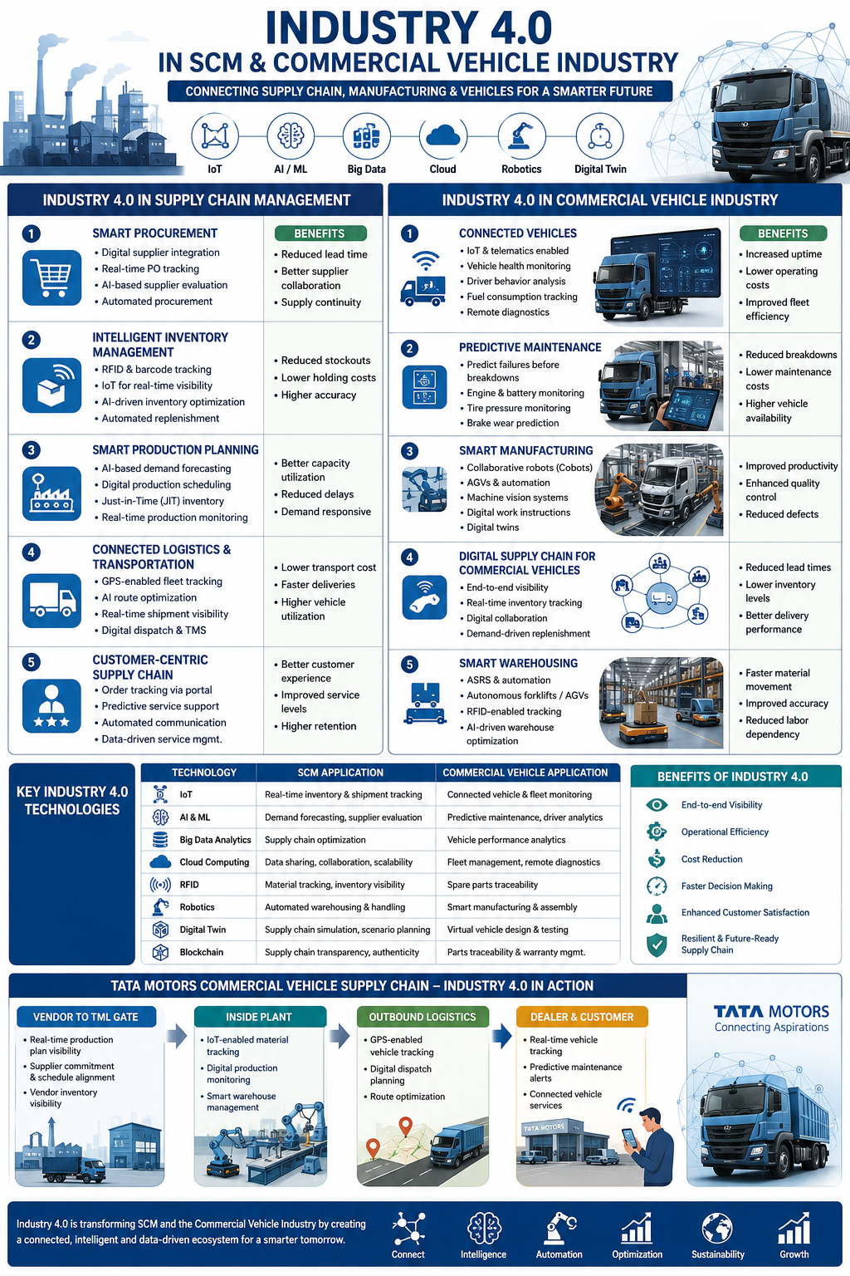

2. Artificial Intelligence (AI) and Machine Learning
AI analyzes large volumes of operational data to support decision-making.
Applications:

Benefits:

3. Warehouse Automation
Automated systems improve material handling and storage operations.
Examples:
- Pick-to-Light Systems
- Hand-Held Terminals (HHTs)
- Automated Guided Vehicles (AGVs)
- Barcode and RFID Systems

4. Big Data Analytics
Large datasets from suppliers, production systems, customers, and logistics providers are analyzed to improve performance.
Applications:
- Supply chain risk analysis
- Inventory optimization
- Supplier performance evaluation
- Demand forecasting

5. Cloud Computing
Cloud platforms facilitate data sharing among suppliers, manufacturers, and distributors.
Benefits:

6. Robotics and Automation
Industrial robots perform repetitive and high-precision tasks.
Applications in Automotive Plants:
- Welding
- Painting
- Material handling
- Assembly operations

Industry 4.0-Based Supply Chain at Tata Motors Commercial Vehicles
Digital Transformation in Supply Chain Management
Procurement:
Procurement processes have become more efficient through digital supplier integration, which enables seamless communication and collaboration between manufacturers and suppliers. Real-time purchase order tracking provides visibility into order status at every stage, reducing delays and improving planning accuracy. Additionally, supplier performance monitoring systems help evaluate vendors based on quality, delivery reliability, and responsiveness, thereby supporting strategic sourcing decisions and strengthening supplier relationships.
Inventory Management:
Modern inventory management leverages RFID and barcode technologies to accurately track materials and components throughout the supply chain. Real-time inventory visibility allows organizations to monitor stock levels continuously, minimizing the risks of stockouts and excess inventory. Furthermore, automatic stock replenishment systems use predefined inventory thresholds to generate replenishment orders automatically, ensuring uninterrupted production and optimized inventory carrying costs.
Production Planning:
Advanced production planning utilizes Artificial Intelligence (AI)-based demand forecasting to predict market requirements more accurately and align production schedules accordingly. The adoption of Just-in-Time (JIT) inventory management ensures that materials are received only when needed for production, reducing storage costs and inventory waste. These practices are further supported by lean manufacturing principles, which focus on eliminating non-value-added activities, improving process efficiency, and enhancing overall productivity.
Logistics and Transportation:
Digital technologies have significantly improved logistics and transportation operations through GPS-enabled fleet tracking systems that provide real-time visibility of vehicle locations and shipment status. Route optimization tools analyze traffic conditions, delivery schedules, and transportation costs to identify the most efficient routes, thereby reducing fuel consumption and transit time. In addition, digital dispatch management systems streamline vehicle allocation, shipment scheduling, and delivery coordination, ensuring timely and reliable transportation services.
Customer Service:
Customer service has been enhanced through real-time vehicle tracking, which enables customers to monitor the status and location of their orders throughout the delivery process. Improved supply chain coordination also ensures faster availability of spare parts, reducing vehicle downtime and enhancing customer satisfaction. Moreover, predictive maintenance support utilizes data analytics and sensor technologies to identify potential equipment failures before they occur, allowing proactive maintenance interventions that improve vehicle reliability and operational performance.
Benefits of Industry 4.0 Supply Chain over Traditional Supply Chain

Challenges in Implementation
- High initial investment
- Cybersecurity risks
- Employee training requirements
- Integration with legacy systems
- Data management complexity

Future Scope

Conclusion:Industry 4.0 in Supply Chain Management for the Commercial Vehicles Industry
Industry 4.0 has transformed supply chain management in the automotive industry by enabling digital connectivity, automation, and real-time decision-making. For commercial vehicle manufacturers like Tata Motors, Industry 4.0 technologies enhance inventory control, improve production efficiency, reduce operational costs, and strengthen supply chain resilience. As the automotive sector moves toward smart manufacturing, Industry 4.0 will remain a key driver of competitiveness and operational excellence.

Conclusion and Key Takeaways from the Internship

The summer internship at Tata Motors Commercial Vehicles, Lucknow Plant, provided valuable practical exposure to the application of modern supply chain management practices in a large-scale automotive manufacturing environment. The study focused on understanding how technology-enabled systems and lean management principles contribute to operational efficiency, inventory optimization, material flow management, and overall supply chain performance.
During the internship, various digital and operational tools such as PTL (Pick-to-Light), HHT (Hand-Held Terminal), and Samprawah were examined to understand their role in streamlining warehouse and logistics activities. The implementation of PTL was found to significantly improve picking accuracy and reduce material handling errors by providing visual guidance to operators. Similarly, HHT devices enhanced real-time data capture, inventory visibility, and transaction accuracy, thereby reducing manual intervention and improving process reliability. The Samprawah platform facilitated better information flow, process monitoring, and coordination among different supply chain stakeholders, supporting data-driven decision-making.
The study also highlighted the importance of inventory control techniques in maintaining an optimal balance between material availability and inventory carrying costs. Effective inventory management practices help prevent stock-outs, minimize excess inventory, improve working capital utilization, and ensure uninterrupted production operations. The integration of digital technologies with inventory management systems further strengthens visibility, traceability, and responsiveness across the supply chain.
Another significant aspect of the study was the evaluation of lean practices implemented at the plant. Lean principles such as waste elimination, process standardization, continuous improvement, and efficient resource utilization play a crucial role in enhancing operational productivity. The observations made during the internship demonstrated how lean methodologies help reduce non-value-added activities, improve workflow efficiency, and create a culture of continuous improvement within the organization.
The internship also provided insights into the challenges and opportunities associated with managing complex automotive supply chains. In an increasingly competitive and dynamic business environment, organizations must leverage advanced technologies, digital tools, and process optimization techniques to achieve higher levels of efficiency, agility, and customer satisfaction. Tata Motors has effectively adopted these practices to strengthen its supply chain operations and support its manufacturing excellence initiatives.
Overall, the internship experience bridged the gap between academic knowledge and industrial practice. It enhanced understanding of real-world supply chain operations, warehouse management systems, inventory control mechanisms, and lean manufacturing concepts. The learning gained through interactions with industry professionals, observation of operational processes, and analysis of technological applications has contributed significantly to professional development and industry awareness. The experience has provided a strong foundation for future career opportunities in supply chain management, operations, logistics, and industrial engineering, while reinforcing the importance of technology-driven innovation sin modern manufacturing organizations.

